

INTER-IoT-EWS

D2.1 – Scenario and use cases

University of Twente, Netherlands

João Moreira ([j.luizrebelomoreira@utwente.nl](mailto:j.luizrebelomoreira@utwente.nl))

+31(0)53 4894337 / +31(0)6 17108979

Building Zilverling 4074, P.O. Box 217, 7500 AE Enschede

Small Collaboration

Abstract

In accordance with the INTER-IoT challenges [1], we intend to support the semantic and syntactic interoperability among IoT artefacts and early warning systems (EWS), i.e. enable data to be understandable for both sender and receiver. In particular, we focus on coordinating emergency services based on IoT devices, alerting the involved parties (e.g. emergency command control, first responders and employees) when an accident occurs.

Our objective is to test the applicability of INTER-IoT solutions in the context of semantic interoperability capabilities of the INTER-IoT framework through the IoT-based EWS, enabling data exchange among heterogeneous IoT artefacts by developing emergency application services that use IoT semantic translations provided by INTER-IoT Inter-Platform Semantic Mediator (IPSM) component. Furthermore, we propose a low-cost business model for the cross-domain scenario of accidents at the port of Valencia (id.9), where transportation companies, haulers and insurance companies can benefit from the IoT EWS by reducing disaster risks involving their employees and the goods being transported.

In this deliverable we detail this scenario, based on the INTER-IoT deliverables, especially “D2.4. Use cases manual” and the interactions with the consortium participants (SRI-PAS, UNICAL, VPF. We give a more detailed description of the scenario with the involved stakeholders, their roles and goals, the requirements from INTER-IoT project (D2.2), the involved IoT artefacts and related scenarios. Then, we describe the changes from the original description and the detail of the use cases to be satisfied by the EWS. For example, one use case will support the detection of vehicle collision based on accelerometer data, while other use case will support the detection of dangerous changes on the vital signs of the driver. These use cases are mixed towards the prediction of accidents (identification of accident risks) and the early detection of the occurrence of accidents.

Contents

Abstract 2

Contents 3

1 Accidents at the port area scenario 4

1.1 Description 4

1.2 Stakeholders 7

1.3 Goals 8

1.4 Requirements 11

1.5 IoT artefacts involved 15

1.5.1 Fleet Management system: Movildata 16

1.5.2 Valenciaport Port Community System (PCS) 17

1.5.3 Truck’s owner (haulier) IoT platform 17

1.5.4 Port Control System 17

1.5.5 Emergency Control Centre IoT platform 17

1.5.6 Port authority IoT platform 17

1.5.7 IoT solution for INTER-Health 18

1.5.8 Accelerometer data provider (Android-based mobile application) 21

1.5.9 Azure IoT platform 21

1.6 Related scenarios 21

1.7 Terms and definitions 22

2 Use cases 23

2.1 UC01: Vehicle collision detection 26

2.2 UC02: Hazardous change in driver’s vital signs 30

2.3 UC03: Vehicle collision related (temporarily) with changes in driver’s vital signs 34

2.4 UC04: Vehicle in wrong way 35

2.5 UC05: Accident involving dangerous goods 35

2.6 Risks identified for the implementation of the use cases 36

References 36

# Accidents at the port area scenario

## Early Warning System

An early warning system (EWS) is a distributed system that monitors the physical world and issues warnings if it detects abnormal situations. The Internet-of-Things (IoT) offers opportunities to improve monitoring capabilities of EWS and to realize (near) real-time warning and response. The INTER-IoT-EWS goal is to detect accident risks with trucks that deliver goods at the Valencia port area, interoperating different IoT platforms. The solution addresses the semantic integration of a variety of data sources with processing in safety-critical applications for effective emergency response. The solution considers existing domain-specific ontologies and standards, along with their serialization formats. Accident risks are assessed by monitoring the drivers’ vital signs with ECG medical wearables, and the trucks’ position with speed and accelerometer data. Use cases include the detection of health issues and vehicle collision with dangerous goods. This EWS is developed with the SEMIoTICS framework, which is composed of a model-driven architecture that guides the application of data representations, transformations and distributed software components. This framework enables EWSs to be a semantic broker for situation-aware decision support.

## Description

In this document the cross-domain scenario (INTER-LogP and INTER-Health) of “Accidents at the port area” (id.9) [2] is detailed as a result of the requirement analysis and solution proposal discussed along with INTER-IoT team (SRIPAS, UNICAL, VPF and UPV). It serves as the initial specification describing the scenario use cases and their requirements, which will be addressed by the IoT Early Warning System (INTER-IoT-EWS), considering an adequate scope for budget and deadline constraints. Figure 1 describes the main elements of the INTER-IoT-EWS architecture according to our research on disaster management supported by integrated EWSs [3, 4].

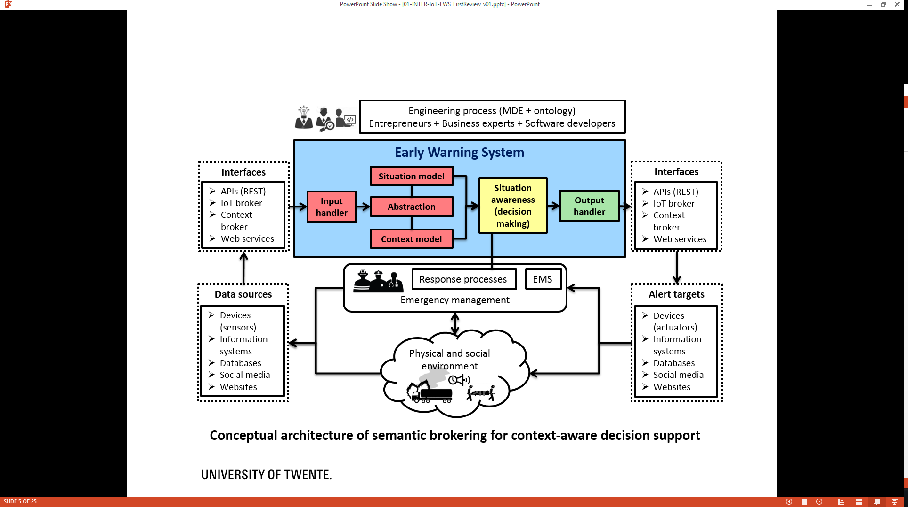

Figure 1: Framework for interoperable situation-aware IoT Early Warning System

INTER-IoT-EWS will be deployed at the application layer of the INTER-IoT framework, reusing the available services offered by the AS2AS (Application & Services to Application & Services) layer, to detect accidents at the port area. Therefore, we aim on creating composite services on top of AS2AS layer, following the INTER-IoT reference model [5]. When necessary, the INTER-IoT-EWS will consume messages that have been translated by the Inter-Platform Semantic Mediator (IPSM) using a dedicated component exposed in the AS2AS layer to enable the integration among IoT platforms and devices using different ontologies. In particular, the INTER-IoT-EWS project collaboration will provide semantic translations between the W3C Semantic Sensor Network (SSN) and the Smart Appliances REFerence (SAREF) ontologies to be configured within IPSM. Therefore, the IoT platforms and/or devices used in this scenario shall be semantically enriched with ontology representations, especially with SSN and SAREF, but can also make use of the IPSM central ontology. Figure 2 illustrates INTER-IoT-EWS collaboration approach.

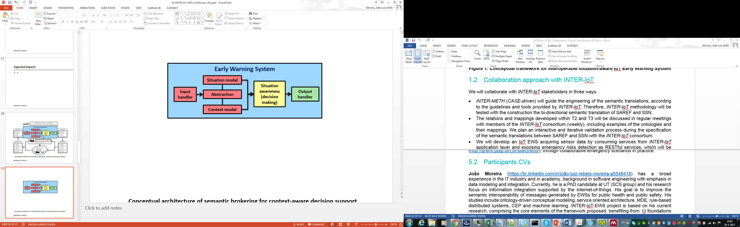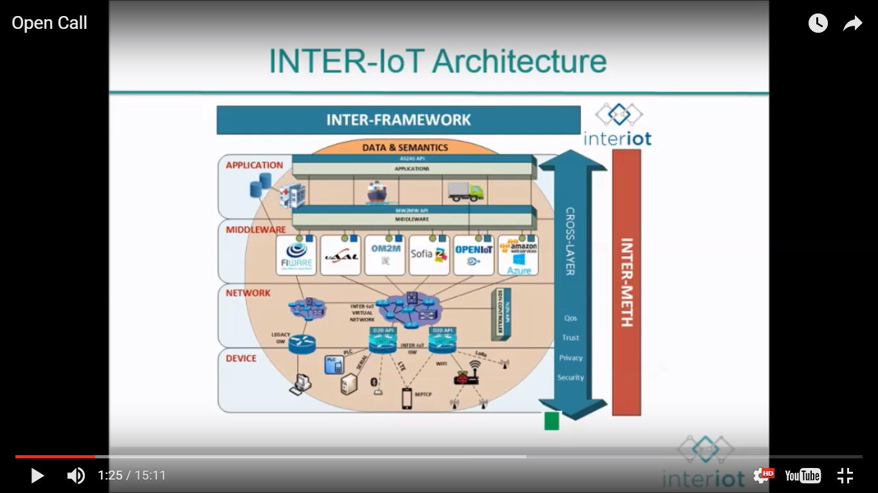

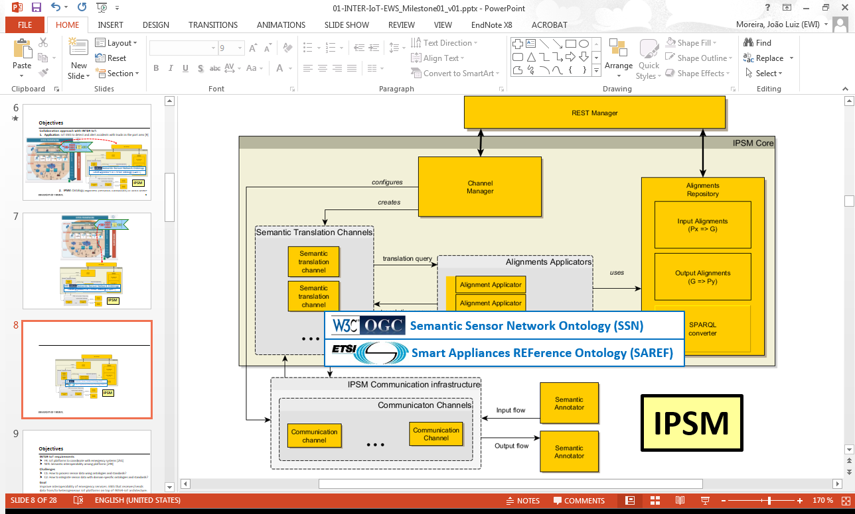

Figure 2: INTER-IoT-EWS collaboration approach

The Valencia port emergency control center (CCE) is the main stakeholder in this scenario, since it is the responsible to respond emergencies at the port area, thus, it should be notified if an accident is predicted (risk identified) and/or when an accident is detected by the INTER-IoT-EWS, as illustrated in Figure 3. This scenario shows how an IoT platform can coordinate with emergency systems, which is part of one of the main requirements of INTER-IoT project, i.e. “create new services to access different platforms” (id.248) [6]. Data about incidents at the port, which can be extracted from the PCS (Port Community System), will be integrated with data from the terminal and the hauler IoT platforms. This data includes the location of trucks and containers with GPS tracking devices, the container terminal management system and health sensors attached to the drivers. To support these medical devices, a cloud platform will be used, i.e. the BodyCloud from UNICAL [7] for body sensor networks (BSNs). As will be described in chapter 2 of this document, one use case within this scenario is to detect the risk of a vehicle collision transiting the port area, by checking the changes on driver’s vital signals, whether they are considered dangerous or not. This use case can include automated alerting to ambulances when victims are reported, following the CCE processes with a similar use case of HL7 – EDXL-TEP transformations[1] for incoming victims from the port area to the ambulance.

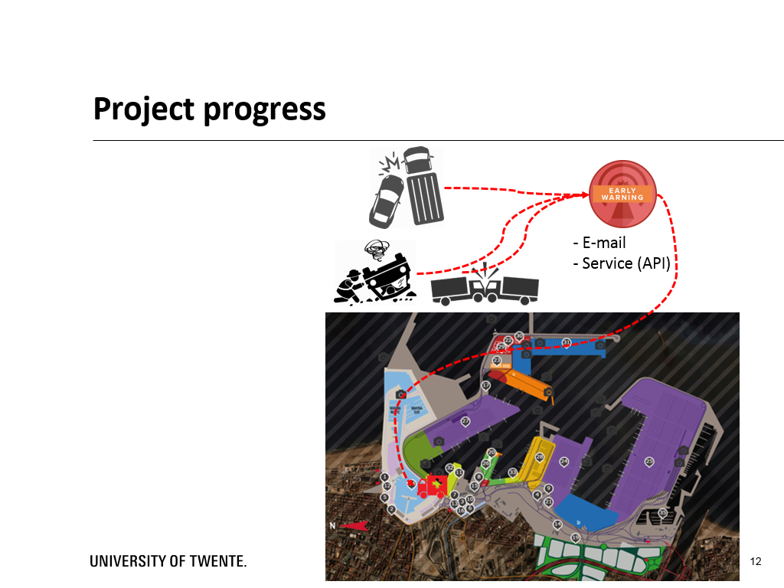

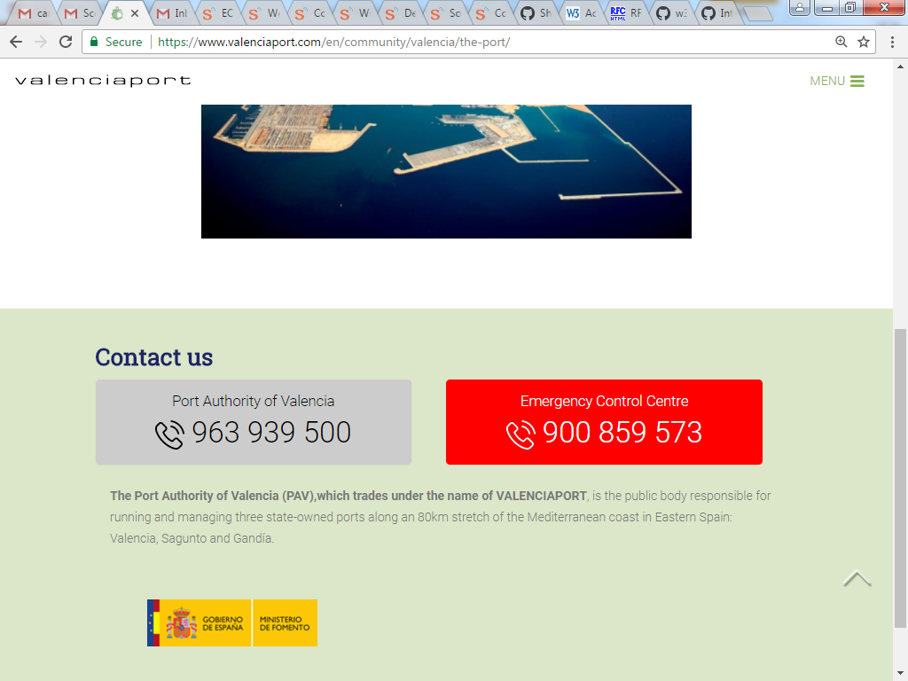

Figure 3: Example of the EWS detecting accidents and alerting the CCE

## Stakeholders

According to the INTER-IoT use cases manual [2], initially, the main actors involved were listed and are described in columns 1 and 2 of the table below. We derived the involved stakeholders from these actors:

|  |  |  |
| --- | --- | --- |
| **Actor** | **Description** | **Stakeholder** |
| Vehicle | It is the physical entity of the scenario. It access to the port facilities. | Haulier (owner of the vehicle who manages the drivers) |
| Driver | He is the user who is driving the vehicle and he has health sensors. He has a health issue or an accident inside the port. | Haulier (employee) |
| Ambulance | It is an external which that is guided by the emergency control centre of the port authority when it is inside the port facilities. | Inside the port: CCE  Outside the port: hospital, civil defense of Valencia, firefighters (?) |
| Road haulier IoT cloud platform | It’s the platform of the owner of the vehicle and it is used to manage all the vehicles and drivers of the company. It monitors the health sensors of the driver. | Haulier (manager and/or coordinator) |
| Port authority IoT platform | It’s the platform that manages all the systems of the port. | Valencia port authority |
| Container terminal IoT platform | It’s the platform that manages all the systems of the container terminal. | Terminal operator (manager and/or coordinator) |

Therefore, the initial list of stakeholders are:

1. Valencia port authority
   1. Manager / coordinator
2. Haulier company
   1. Driver
   2. Manager / coordinator
3. CCE
   1. Emergency manager
   2. First responders
4. Terminal operator company
   1. Manager / coordinator
5. Hospitals
   1. Manager / coordinator
   2. First responders within ambulance
6. Valencia civil defense
   1. Emergency manager
   2. First responders
7. Firefighters
   1. Emergency manager
   2. First responders

Besides these, from our initial business model, there are also these stakeholders:

1. Health insurance companies
   1. Service / product manager
2. Shipping insurance companies
   1. Service / product manager
3. Transportation customers
   1. People

## Goals

According to the use cases manual [2], the “Inter-Health/LogP are motivated by decreasing fatal accidents at the port and improving safety related to Health conditions accidents. This would be improved by the real time reaction. As well, introducing Health IoT systems in the public transport sector enables emergency medical personnel early access to data available for treatment and improving triage in case of emergencies”. Therefore, the overall goal of this scenario is to “interoperate the wearable medical devices with IoT platforms such as the road haulier company and the port emergency control centre are able to react quickly, thus reducing time responses during accidents and health prevention”. The scenarios users’ goals are:

1. Valencia port authority and CCE: to detect accidents and react in real time.
2. Haulier companies: to improve the safety of their drivers and reduce accidents



Figure 4: Classification of stakeholder types [8]

Based on our design science methodology [8], we classified the stakeholders according to the list above, described in the table below. The “system under development (SUD)” is the INTER-IoT-EWS:

|  |  |  |  |
| --- | --- | --- | --- |
| **Organization** | **Stakeholder** | **Classification** | **Interaction EWS** |
| Valencia port authority | Manager / coordinator | Normal operator (end user).  Maintenance operator.  Operational support.  Functional beneficiary.  Financial beneficiary.  Purchaser.  Developer. | Will provide data about the port internal devices and systems, such as data about the vehicle entrance in the port and the terminal where it goes. Will be responsible for configuring and maintaining the EWS in the cloud infrastructure, developing new functionalities, giving operational support to hauliers and to CCE.  Benefits by receiving early warnings of possible accidents, reducing disaster risks at the port area.  Benefits financially by avoiding the impact of accidents for the operational activities of the port.  Will provide budget to maintain the cloud infrastructure of the EWS. |
| Haulier company | Driver | Normal operator (end user).  Functional beneficiary. | Will provide real-time data to the EWS through e-health sensors, along with the truck’s location and speed (mobile).  Benefits by receiving early warnings, avoiding accidents and/or receiving faster response to an emergency. |
| Haulier company | Manager / coordinator | Normal operator (end user).  Functional beneficiary.  Financial beneficiary.  Purchaser. | Will provide data to the EWS about the driver, the vehicle and the shipment.  Benefits by receiving early warnings of possible accidents, reducing emergency risks with their employees (drivers) and the shipment being delivered.  Benefits financially by avoiding the impact of accidents for the operational activities of the port.  Will provide budget to maintain the cloud infrastructure of the EWS. |
| CCE | Emergency manager | Normal operator (end user).  Functional beneficiary. | Will be able to monitor incidents detected by the EWS.  Benefits by receiving early warnings of possible accidents, being able to faster manage the emergency response activities. |
| CCE | First responders | Functional beneficiary. | Benefits by receiving early warnings of possible accidents, being able to respond faster to disaster risks at the port area. |
| Terminal operator company | Manager / coordinator | Normal operator (end user). | Will provide data about the containers being delivered by the vehicle (e.g. inflammable or sensitive shipments). |
| Hospitals | Manager / coordinator | Functional beneficiary. | Will be able to respond faster to accidents. |
| Hospitals | First responders within ambulance | Functional beneficiary. | Will be able to respond faster to accidents. |
| Valencia civil defense | Emergency manager | Functional beneficiary. | Will be able to respond faster to accidents. |
| Valencia civil defense | First responders | Functional beneficiary. | Will be able to respond faster to accidents. |
| Firefighters | Emergency manager | Functional beneficiary. | Will be able to respond faster to accidents. |
| Firefighters | First responders | Functional beneficiary. | Will be able to respond faster to accidents. |
| Health insurance companies | Service / product manager | Financial beneficiary.  Purchaser. | Health insurance companies providing services to hauliers and port, for their employees, will benefit by the reduction of accidents and the response time of emergencies at the port. Therefore, the companies will have less health related costs with the insured people. A sustainable business model splits the costs of the EWS maintenance among the health and shipping insurance companies, the port authority and the haulier. |
| Shipping insurance companies | Service / product manager | Financial beneficiary.  Purchaser. | Equivalent to health insurance companies, the shipping insurance companies providing services to the hauliers will benefit because of the reduction of accidents, thus, less damage to the load being transported. It will also provide a small amount of budget to maintain the EWS. |
| Transportation customers | People | Functional beneficiary. | Will benefit because of the reduction of accidents, thus, less losses of the transported items. |

## Requirements

According to [6], the INTER-LAYER requirements include the non-functional requirement “Semantic and syntactic interoperability” (id.180), which is described as:

**R01.** “The mixing and mashing of data gathered by many IoT applications adds values to the collected data as a whole and to facilitate such data exchanges, the IoT applications require common data formats and application programming interfaces (APIs) so data can be accessed and combined as needed. For achieving semantic interoperability, syntactic interoperability must be enabled. It can be achieved through simple translation. IoT Platform Semantic Mediator can receive requests in selected data formats and semantics and translate them to the data formats and semantics of target IoT platform. IoT Platform Semantic Mediator provides interfaces for data interchange formats at least such as OWL, RDF, XML, and JSON.”

The acceptance criteria to address this requirement is a mechanism “to translate data format and semantics of exchanged message to achieve communication with common understanding on both sides. Syntactic interoperability among different protocols, W3C SSN, ETSI SAREF and One M2M as a minimum. FI-WARE and OGC SensorThing as a may”.

Other requirements related to INTER-IoT-EWS, within the INTER-LogP scope [6], are:

**R02.** NFR of creating new services to access different platforms (id.248). “Access to resources and services of a virtual entity from another IoT platform or application when certain rules are met”. The acceptance criteria to address this requirement is to evaluate whether the port IoT platform, the terminal IoT platform and the haulier IoT platform can exchange data about the trucks and containers entering in the port area. In particular, to address this requirement, the involved IoT platforms have to coordinate with emergency systems.

**R03.** NFR of enabling semantic interoperability among platforms (id.249), requiring that the data provided by an IoT platform to another IoT platform must be understandable for the receiver platform. The acceptance criteria to address this requirement is to make the data provided by a road haulier IoT platform (about a truck) to be understandable by the port IoT platform.

The most notable requirement related to INTER-IoT-EWS is:

**R04.** FR of enabling the ability of IoT platforms to coordinate with emergency systems (id.251). “In environments where there may be some risks for people, IoT platforms must be able to contact and coordinate automatically with emergency services when an accident occurs”. The acceptance criteria to address this requirement is to check if the port IoT platform is able to coordinate with emergency systems located in the vicinity of the port.

According to [2], the interoperability requirements to be addressed for this scenario are:

**R05.** Data & Semantics: There should be primitives for data interpretation in the different platforms (e.g. medical data).

**R06.** Application Services: There should be primitives between the haulier IoT platform and the port IoT platform for sharing information about the driver. The haulier company monitors the health of their drivers at any times. The haulier IoT cloud platform and the port emergency control system share security and safety information.

**R07.** Middleware: The personal health device alerts the haulier IoT platform.

**R08.** Networking: There should be primitives to connect the truck to the port platform.

**R09. “**The testing of this scenario could be part of emergency simulation exercises that are executed periodically at the port area”.

The main question to be responded in this scenario is:

“How e-Health and e-Care could use IoT platforms dedicated to transport to prevent the occurrence of accidents and to support evacuation or attention in case of emergency situations”?

We derived from this question and the requirements two main challenges:

* **C1:** How to process sensor data using ontologies and standards such as SAREF, W3C SSN, OASIS EDXL-DE (distribution) and EDXL-RM (sensor allocation)?
* **C2:** How to integrate sensor data with domain-specific ontologies and standards? In the emergency domain, relevant ontologies and standards include OASIS EDXL for alerting (CAP), situation reporting (SitRep), tracking victims (TEP) and hospital availability (HAVE); and can include e-Health, logistics and environmental.

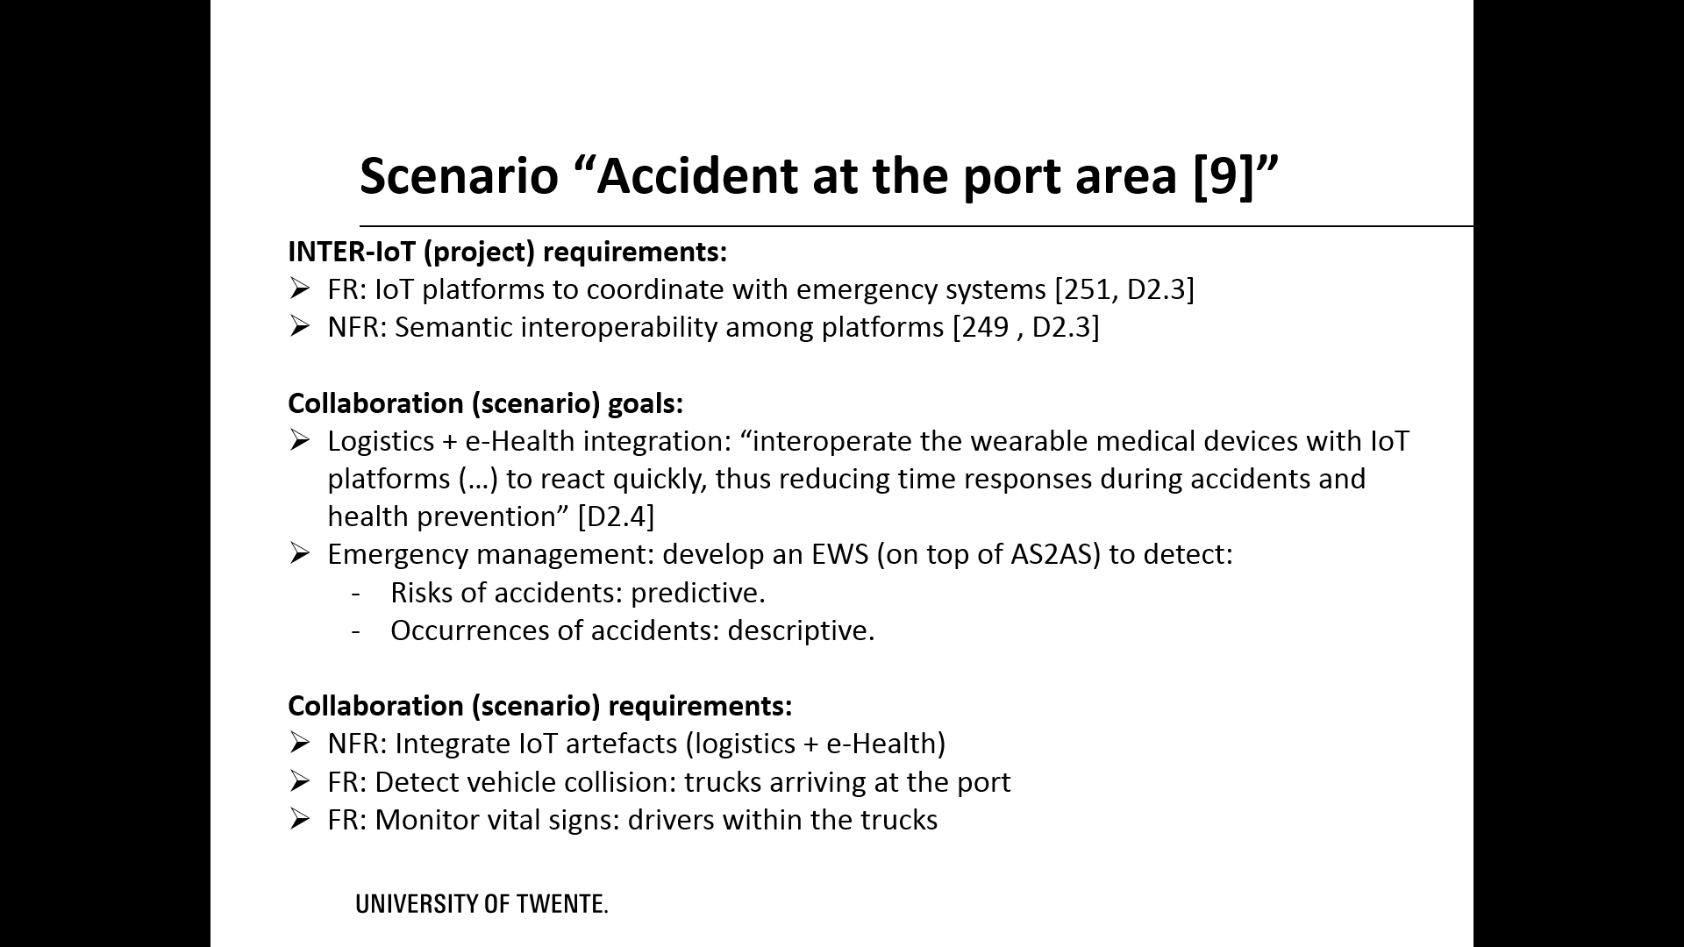

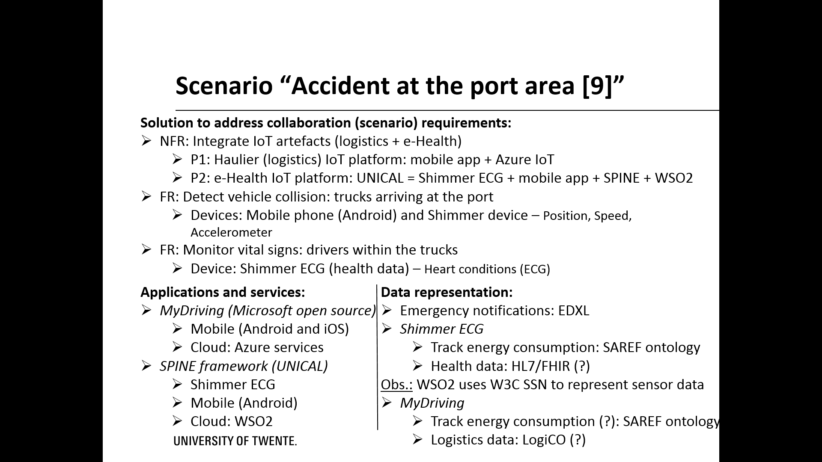

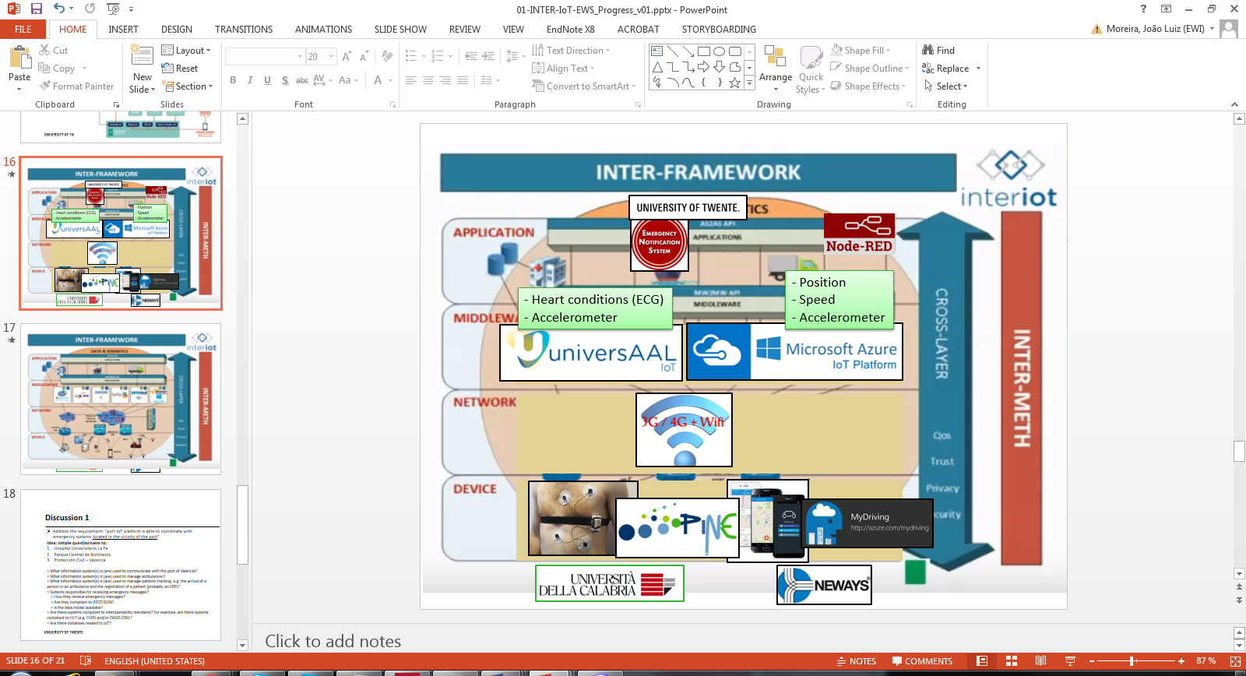

## IoT artefacts involved

According to the terminology used by the INTER-IoT reference model [5], in this section we list the “IoT artefacts”, i.e. platforms, devices, gateways, applications, etc., that can be used to support the implementation of this scenario. These IoT artefacts will produce data to be consumed by the EWS end users (normal operators). According to the use cases manual [2], the produced data by this scenario are:

* Driver’s medical data
* Truck position

The consumed data are:

* Safety events.

According to the “scenarios by interacting systems” [2], the devices, equipment, connectivity and platforms that were planned to be used in this scenario are described in the table below.

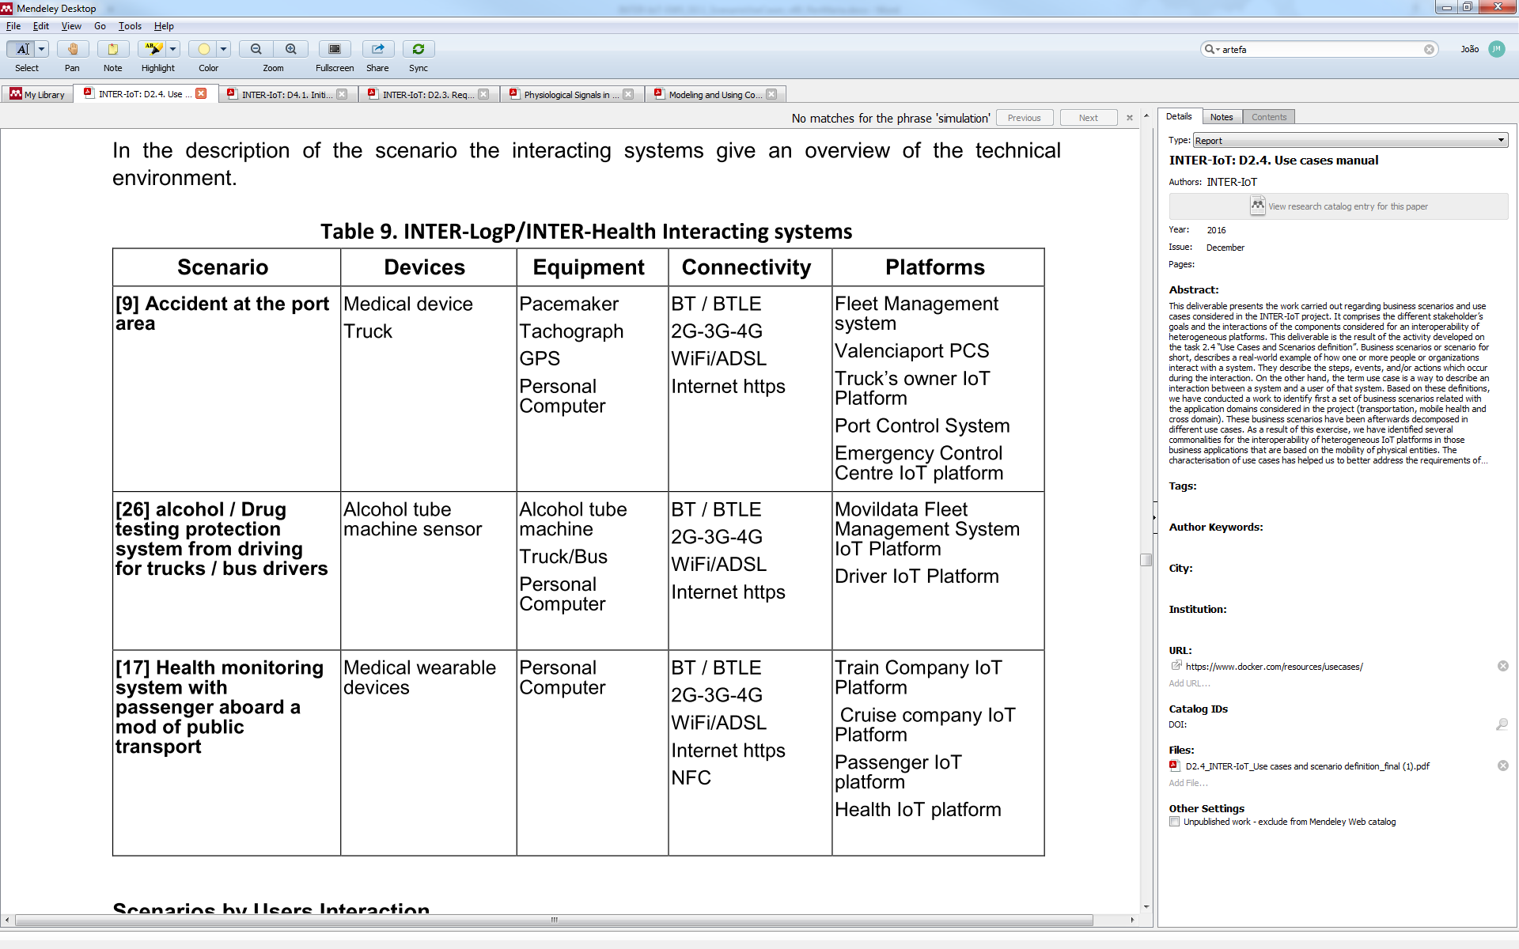

Figure 5: IoT artefacts of the accidents ate the port area scenario [2]

The devices (medical device and the truck) will still be used. The medical device refers to the Shimmer 3 ECG[2], which is a sensor providing vital signs’ real-time data, to be attached to the driver’s arm and wired to electrodes attached to the driver’s chest. The truck refers to the vehicle of the haulier which the driver uses to transport the shipments. Equipment to be used were changed: the pacemaker and personal computer will not be used. Since it will be mandatory from 2019 (EU legislation), a “smart tachograph”[3] can be used to share real-time data about the truck’s speed, location and the driver’s activity. Usually this type of tachograph is directly connected to a fleet management system. Also sharing the truck’s location, the data provided by the GPS used during transportation will be considered. Instead of using a personal computer within the truck, the driver will use an Android-based mobile, which will run application(s) (e.g. the ShimmerCapture) to gather and transmit data through the internet. The connectivity from the devices/equipment to the mobile will be based on Bluetooth (BT) or Bluetooth Low Energy (BT-LE). From the mobile to the internet, the available network will be used, whether connected on 2/3/4G network or via WiFi.

Regarding the platforms to be used, besides the ones listed in the table, the BodyCloud solution [7] will be used to cover the real-time data acquisition from the medical wearable device (Shimmer). Bellow we describe each platform and its role in this scenario.

### IoT solution Shimmer ECG 3

Initially, the solution to cover the INTER-Health scenarios would be based on the BodyCloud approach [7]. The architecture of BodyCloud, illustrated in Figure XX, comprises four modules: body, cloud, analyst and viewer. The Body component includes an e-Health sensor (to be attached on a person), which transmits data to a mobile application (Android-based). The mobile transmits the data to the Cloud, which can expose the access to these data through the Restlet framework, following a modality, i.e. the data representation that must be created by the user – an IoT solution developer – of the Analyst module. Data stored in the cloud can be visualized through the Viewer component through the REST services.

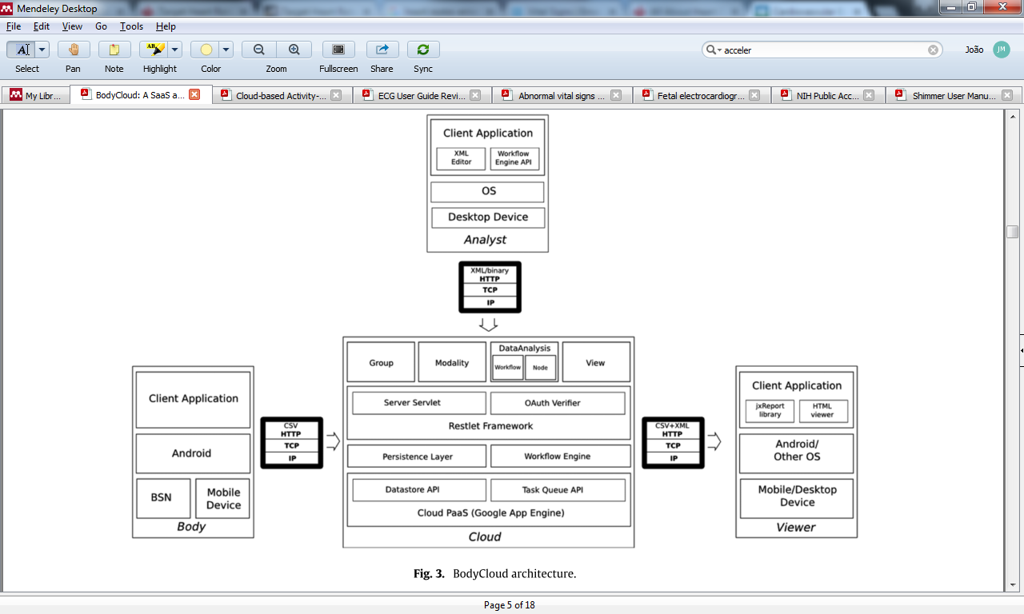

Figure 7: BodyCloud architecture [5]

In particular, the Body component of BodyCloud is implemented with the SPINE framework[4]. “SPINE (Signal Processing in Node Environment) is a software Framework for the design and fast prototyping of Wireless Body Sensor Network (BSN) applications. SPINE enables efficient implementations of signal processing algorithms for analysis and classification of sensor data through libraries of processing functionalities. It also embed an application-level communication protocol. SPINE is organized in two interacting macro-components, which are respectively implemented on commercially available sensor devices and on the personal coordinator (such as an Android smart-phone or tablet, or a personal computer). Communication among these devices is wireless, using the Bluetooth 2.1 or IEEE 802.15.4 standards” [5].

SPINE is compatible with the Shimmer devices’ family[6] (rev. 1.3 and 2R). An application based on the TinyOS (version 2.1) operational system[7], used by Shimmer devices, enables the real-time data transfer (through Bluetooth) from the device to a mobile running the SPINE’s data collector. This approach follows the examples of applications that can be deployed within the Shimmer device microcontroller[8]. As will be seen on chapter 2, these application examples provided by Shimmer can also be useful for detecting vehicle collisions based on accelerometer data, such as the “apps/SimpleAccel”, which streams accelerometer data over Bluetooth.

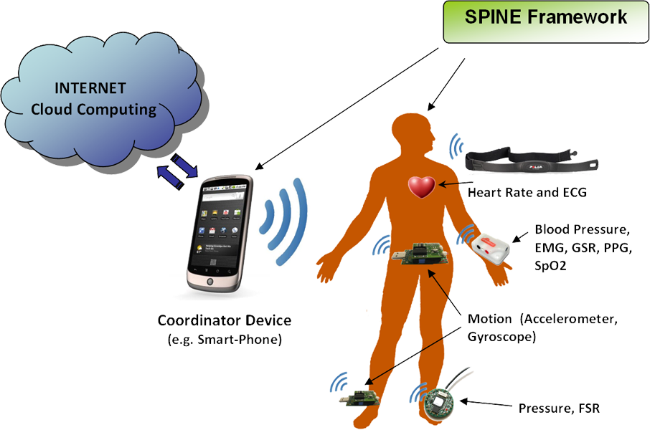

Figure 8: Implementation of Body module with SPINE framework

One of the main Shimmer devices supported by the SPINE framework is the Shimmer ECG for cardiac monitoring. The Shimmer 3 ECG[9] functions are illustrated in Figure XX (left), which include electrocardiogram, respiration, accelerometer and gyroscope. Figure XX (right) illustrates how this device is attached to a person. “The Shimmer3 Consensys ECG Development Kit can be utilized to monitor ECG (Electrocardiogram), recording the pathway of electrical impulses through the heart muscle. The ECG Development Kit can also be utilized to monitor (non-invasive) surface EMG, providing a representation of the muscle activity at the measurement site. Combined with Shimmer’s integrated 9DoF inertial + altimeter sensor platform, greater context can be given to the wearer’s activity and condition in real-time”.

The Shimmer repository for Shimmer3 firmware applications[10] (C language) provides: (1) Configurable Bluetooth sensing and streaming application; (2) configurable sensing application that saves data to microSD card; (3) configurable sensing application that simultaneously logs to microSD card while streaming over Bluetooth; and (4) list of identifiers used by applications to identify themselves. Besides these applications, Shimmer also provides the ShimmerCapture software[11], which allows users to display and save data received from Shimmer devices, working in conjunction with the Shimmer3 LogAndStream to allow simultaneous streaming of data over Bluetooth. Shimmer C# API is the source code of ShimmerCapture application, available for Shimmer website members. To calibrate the tri-axel Accel, Gyro and Mag sensors, Shimmer provides the Shimmer 9DoF Calibration for Android[12]. Once calculated, the calibration parameters can be stored to the Shimmer memory and recalled by other applications allowing for automated calibration of the sensor data.

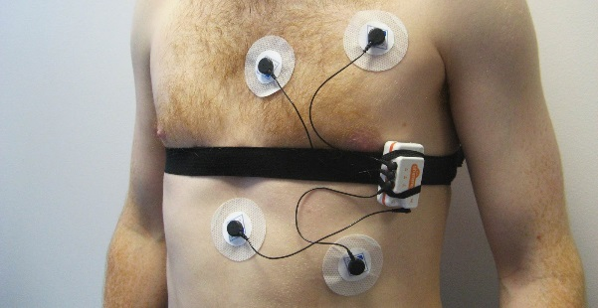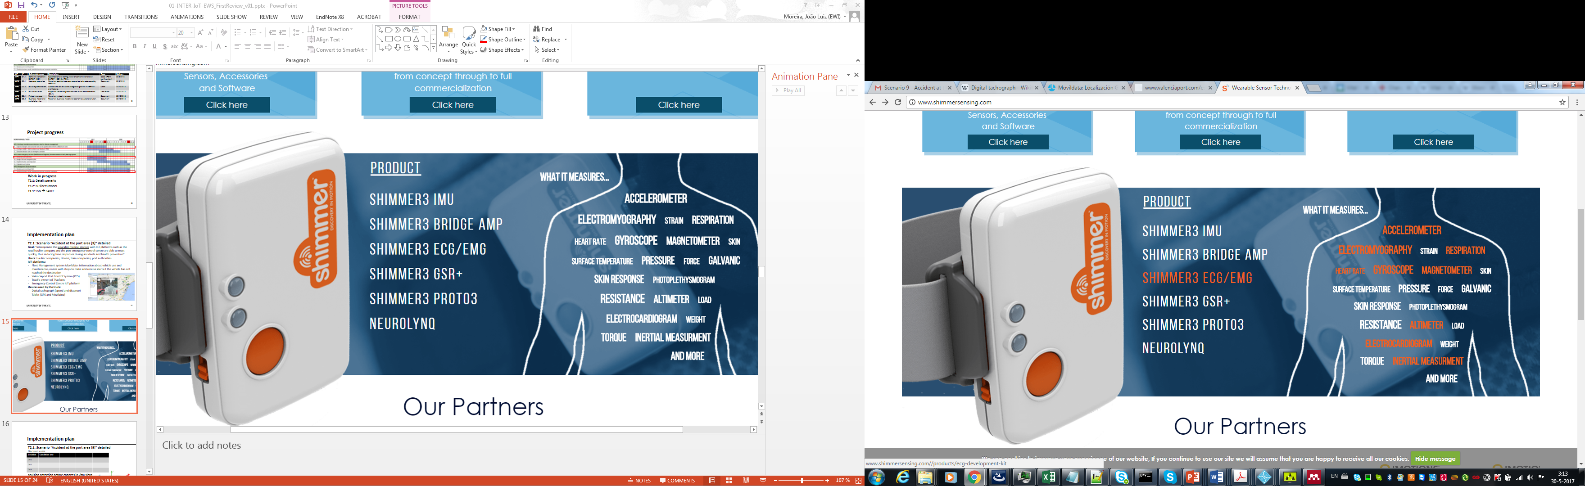

Figure 9: Shimmer 3 ECG/EMG features (left) and usage mode (right)

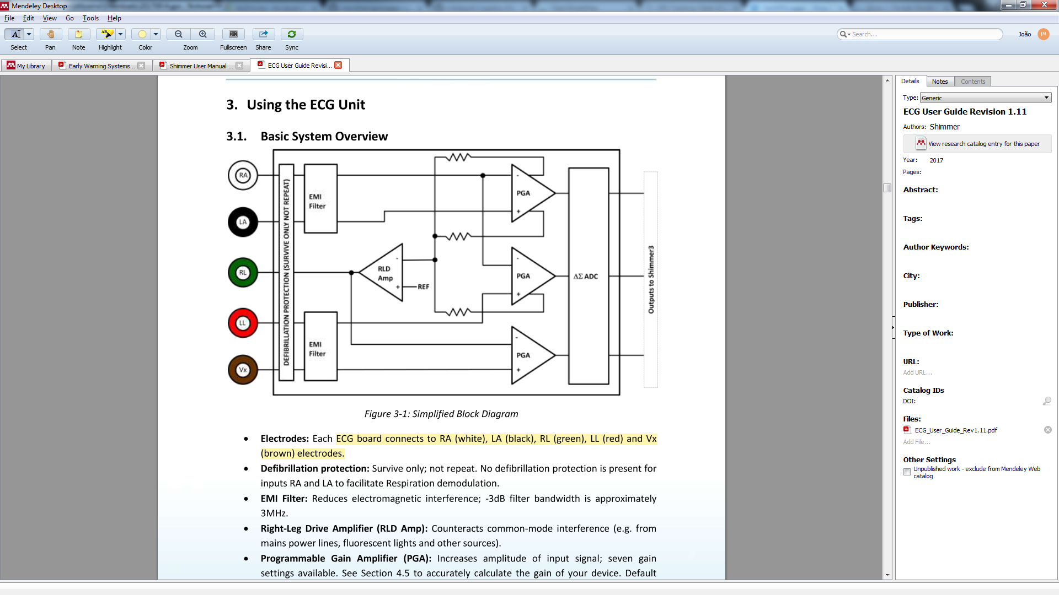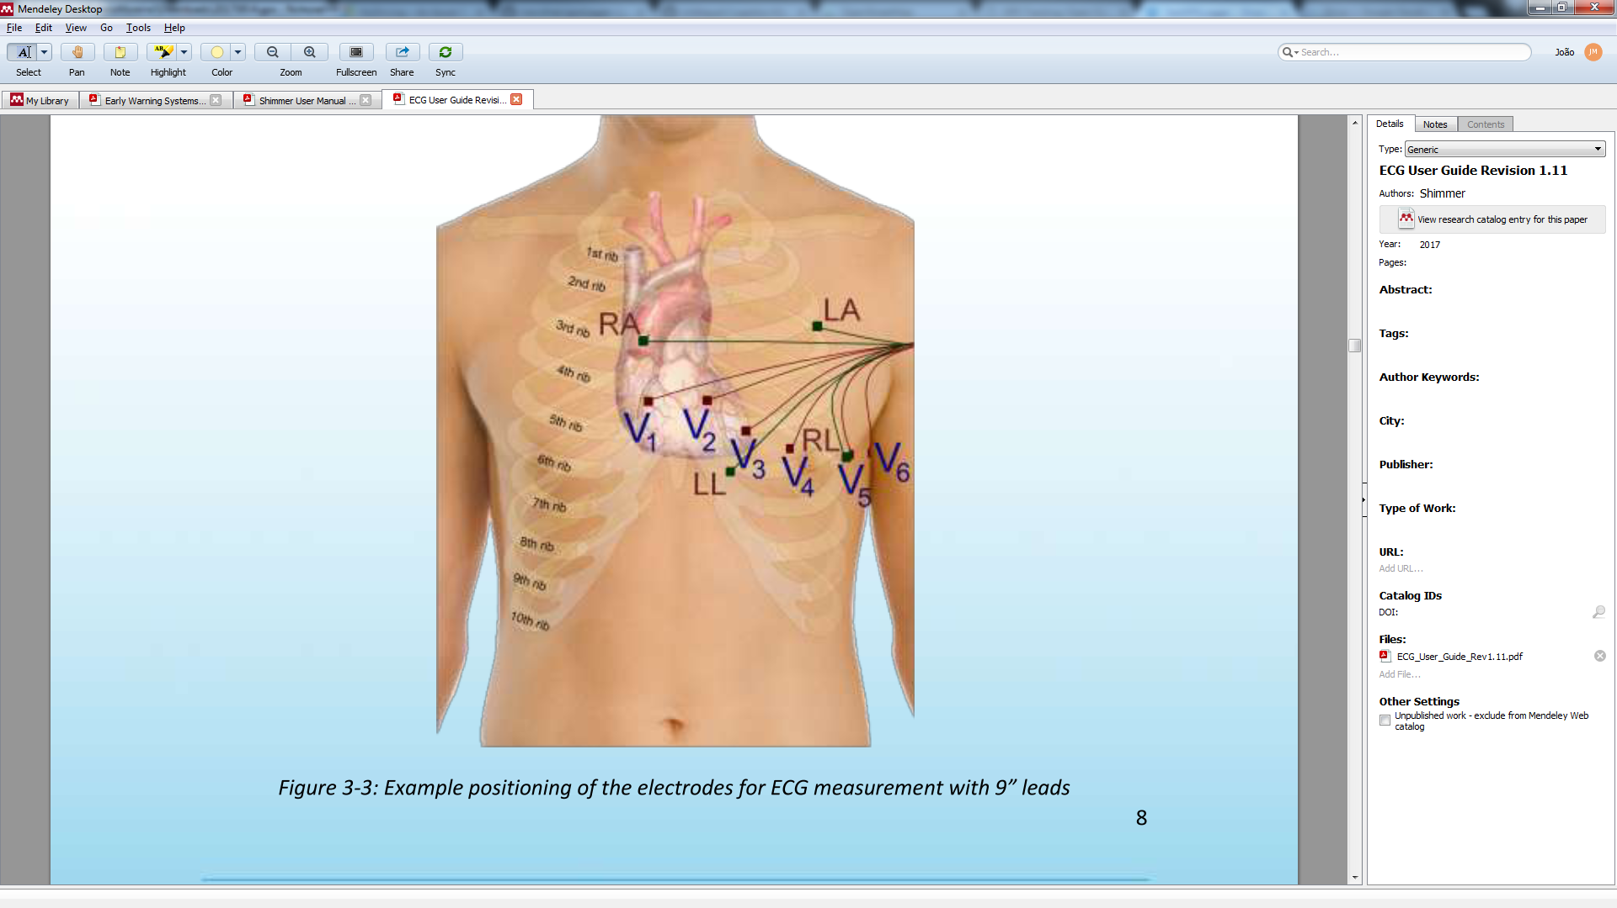

One relevant issue arise from the use of BodyCloud as an IoT platform for BSNs in the INTER-Health scenarios: data privacy and sensitive constraints. The Cloud module of BodyCloud is built on top of the Google App Engine, which is the Google cloud computing platform for developing and hosting web applications in Google-managed data centers. The constraint refers to the restriction of storing clinical data in private clouds, which must be localizable, rather than in Google data centers.

Because of this constraint, the IoT solution for INTER-Health will not consider the Cloud module of BodyCloud, instead, it will make use of the UniversAAL open source IoT platform[13]. UniversAAL is a not-for-profit project (open source[14]) that enables seamless interoperability of devices, services and applications through rapid development of innovative IoT solutions. The rapid evolution of universAAL IoT ensures that new features and applications are regularly added to integrated systems, bringing possibilities to the middleware platform. “With users able to effortlessly share valuable data between devices and systems, there is the flexibility and versatility to build a completely unique lifestyle environment. Interoperability is now a possibility”.

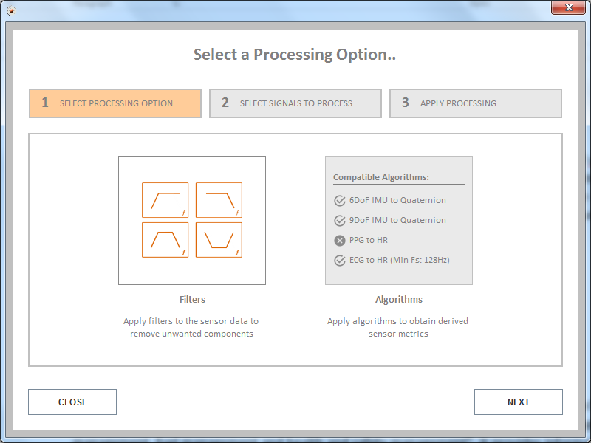

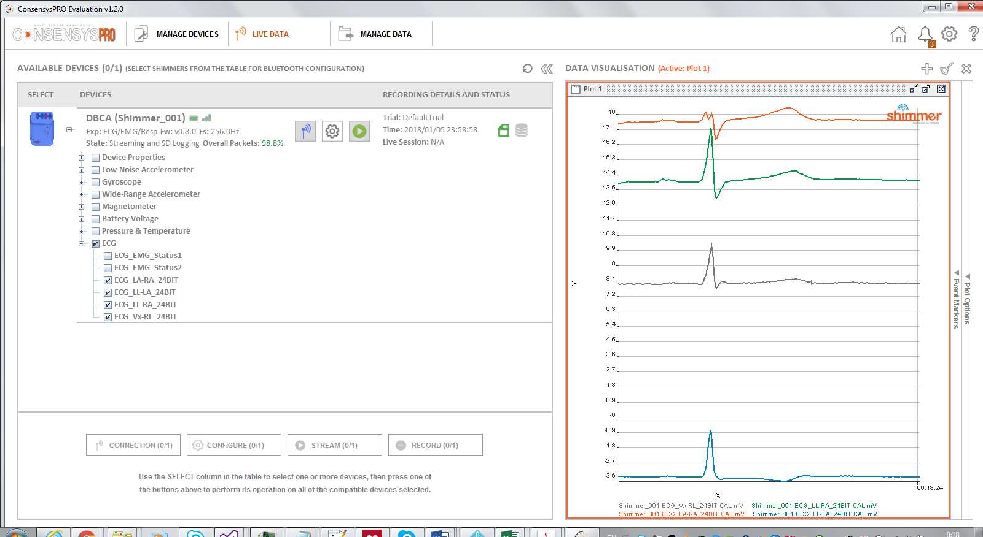

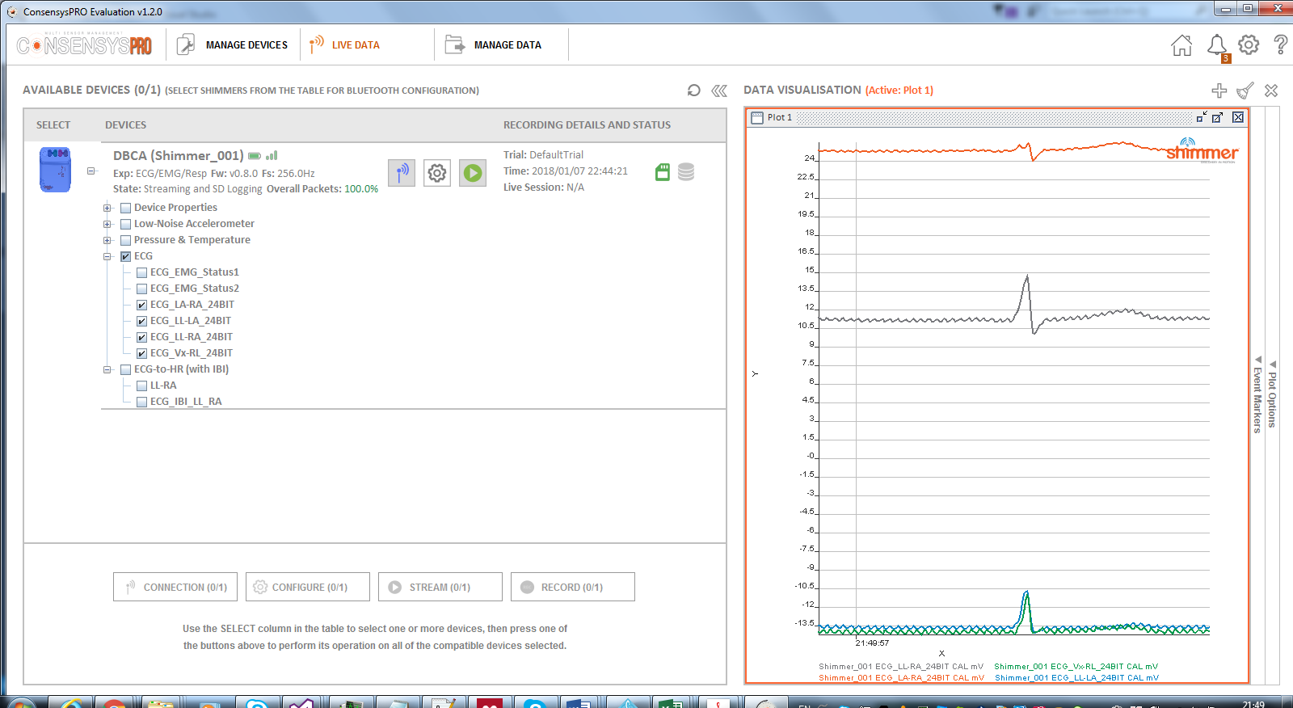

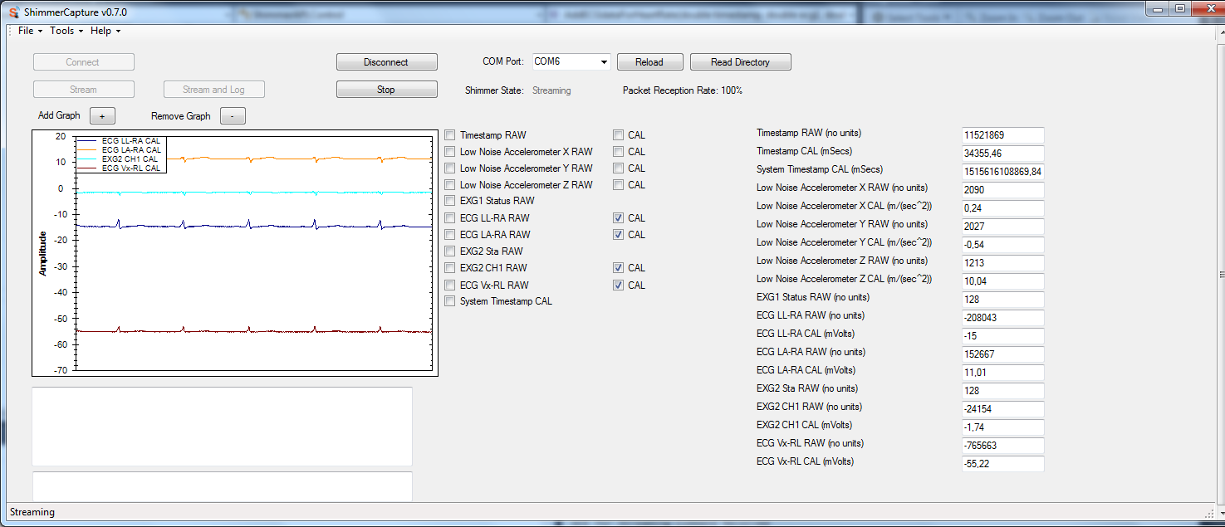

ShimmerCapture C#

### Fleet Management system: Movildata[15]

A fleet management system “is a standard interface to vehicle data of commercial vehicles”, i.e. a system for “vehicle maintenance, vehicle telematics (tracking and diagnostics), driver management, speed management, fuel management and health and safety management”. It provides information about the vehicle use and maintenance, routes with stops to make and receive alerts if the vehicle has not reached the destination. Figure XX illustrates Movildata application UI, that can be used by the haulier manager to track the transportation of goods and manage drivers. Movildata solution can include a tachograph and/or a mobile application to enable data acquisition. Movildata includes features as real-time location, reports and route representation, speed and summary reports, calculation of distance to destination, activity reports by zones, polygon zones and step report, creating routes and verifying their compliance, compliance with working hours and alerts.

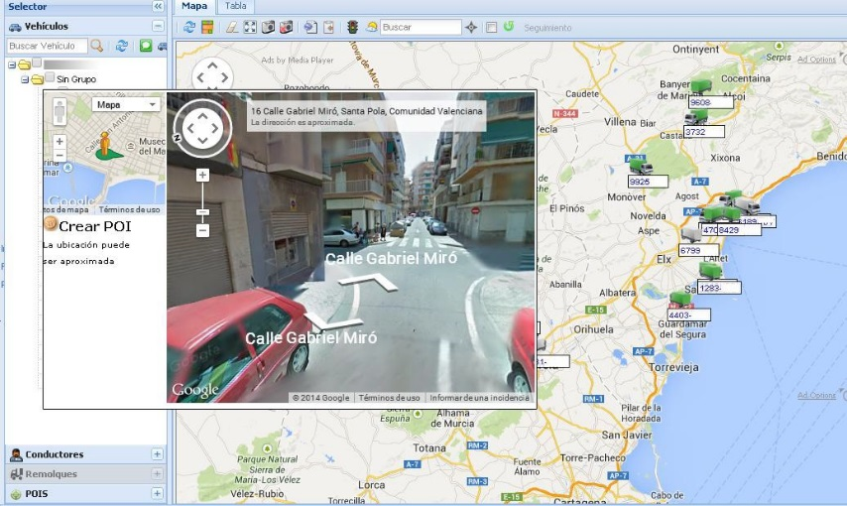

Figure 6: Movildata fleet management system UI

### Valenciaport Port Community System (PCS)

“It is an internal system of the port that access to the data from the port services” [2]

### Truck’s owner (haulier) IoT platform

An IoT platform of the owner of the vehicle (truck) used to manage all the vehicles and drivers of the company, monitoring the health sensors of the drivers.

“Road haulier IoT platform: This is the platform of the road haulier. This platform keeps track of the truck and the driver and it receives information from the port or container terminal about where to pick-up or deliver the container.”

### Port Control System

<< No info about this system >>

### Emergency Control Centre IoT platform

<< No info about this system >>

Besides these initial IoT artefacts listed in the use cases manual, it was included other as follows:

### Port authority IoT platform

“It’s the platform that manages all the systems of the port including the gates to control the arrival and departure of trucks”. such as traffic inside the port, safety inside the port, etc.

“It can send orders to the driver.”

### Accelerometer data provider (Android-based mobile application)

Since an Android-based mobile phone is considered to support this scenario, an application running in the mobile can provide accelerometer data, which is useful for detecting vehicle collisions (see chapter 2). Therefore, an application that sends accelerometer data can be built with support of examples such as the seismograph that displays live accelerometer data[16].

### Azure IoT platform

### UniversAAL IoT platform

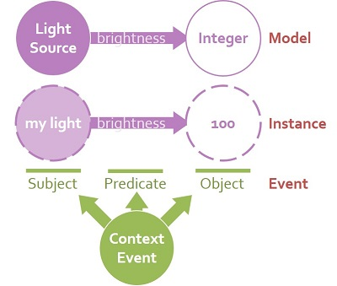

<https://github.com/universAAL/platform/wiki/Understanding-universAAL#What_parts_an_application_is_made_of>

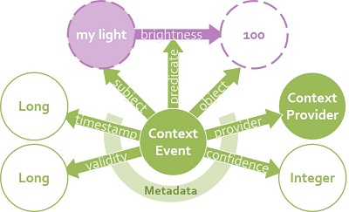

<https://github.com/universAAL/platform/wiki/Context-Bus-%28Quick%29>

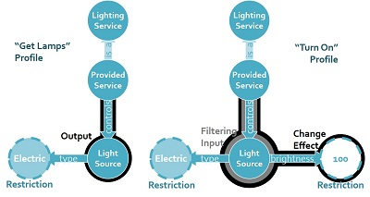

https://github.com/universAAL/platform/wiki/Service-Bus-%28Quick%29

## Related scenarios

The **Health Monitoring System [10] [17]** is the main scenario related to the accidents at the port area. “The objective of these scenarios are to create an IoT cloud platform that will allow passengers of different transportation modes to connect their wearable devices that monitors their ECG, SPO2, blood pressure or temperature. This platform will be connected with their respective e-health or e-care platform and it will establish a new form of triage in order to detect and tackle health problems during long distance trips. The scenario can also be extended to truckers” [2]. The same approach to address this scenario is considered to be used here, as described in section 1.5.7.

The **IoT access control, traffic and operational assistance [30]** “is focused on providing new mechanisms for access controls and trucks monitoring in restricted areas through interoperability of IoT platforms and devices”. Goal: “to build a new service to control access, monitor traffic and assist the operations at the port. Several IoT platforms will be able to identify trucks and drivers using different devices and they will share data under predefined rules through an interoperability of the platforms involved owned by the road hauliers, the port authority and container terminals. (…) More accurate, reliable and resilient information about trucks can be used for security and safety purposes inside the port as well as for operational and optimisation purposes inside the container terminal. The terminal operator will be able to follow up trucks entering to pick up or deliver containers in a similar way as they are monitoring their own machines”.

Other related scenarios:

* **Elderly monitoring [16]**
* **IoT support for transport planning and execution [2]**
* **Transport on truck breaks down or is hijacked [19]**
* **IoT access control, traffic and operational assistance [30]**

## Terms and definitions

**Definition:** “**Accelerometer** measures acceleration or how fast a mass or a body is speeding up or slowing down. Accelerometers can measure in one, two, or three orthogonal axes, X, Y and Z. Acceleration is displayed either in units of meters per second squared (m/s2), or G-force (g), where g = 9.8m/s2. Accelerometers are used to sense both static (e.g. gravity) and dynamic (e.g. sudden starts/stops) acceleration. (…) This has many applications in automotive industry” [9].

The choice of an accelerometer is based on the application (functional requirements), power requirements, communication interfaces, range and additional features (tap detection, free-fall detection, temperature compensation and 0-g range sensing). Accelerometers have a selectable range of forces they can measure. These ranges can vary from ±1g up to ±250g. Typically, the smaller the range, the more sensitive the readings will be from the accelerometer. For example, to measure small vibrations on a tabletop, using a small-range accelerometer will provide more detailed data than using a 250g range (suited for rockets)[17].

In industrial solutions, micro-electro-mechanical (MEMS) technologies with accelerometers and gyroscopes are widely applied. “These accelerometers are physically mounted to the chassis of the car meaning that their motion will directly mirror that of the vehicle and will experience every force the vehicle experiences” [10]. Therefore, when the device is attached within the car in a fixed position, detecting impacts is easier than when the device is not fixed, which is the case here with the medical wearable sensor (Shimmer device) and a mobile phone. To overcome this issue, some approaches, such as [10], increases the threshold for 4g instead of 3g.

Currently (April 2017), the W3C is working on a specification for accelerometers, defining *Accelerometer*, *LinearAccelerationSensor* and *GravitySensor* interfaces for obtaining information about acceleration applied to the X, Y and Z axis of a device that hosts the sensor[18]. In a nutshell, an *Accelerometer* has a default sensor, which is the device’s main accelerometer sensor. A *latest reading* per sensor of accelerometer type includes three entries whose keys are "x", "y", "z" (device’s acceleration about the corresponding axes). Values can contain also device’s *linear acceleration* or *gravity* depending on which object was instantiated. The acceleration is the rate of change of velocity of a device with respect to time, with unit of metre per second squared (m/s2). The frame of reference for the acceleration measurement must be inertial, such as, the device in free fall would provide 0 (m/s2) acceleration value for each axis. The sign of the acceleration values must be according to the right-hand convention in a local coordinate system defined by the device.

The *LinearAccelerationSensor* is an *Accelerometer*, which latest reading contains device’s linear acceleration about the corresponding axes. The *linear acceleration* is an acceleration that is applied to the device that hosts the sensor, without the contribution of a gravity force. The *GravitySensor* is an *Accelerometer*, which latest reading contains device’s acceleration due to the effect of gravity force about the corresponding axes. The gravity is a force that attracts an object to the center of the earth, or towards any other physical object having mass. The local coordinate system of a mobile device is usually defined relative to the device’s screen when the device in its default orientation (see figure below).

# Use cases

The initial specification of the accident at the port area (9) scenario, described in the INTER-IoT use cases manual [2], includes a diagram of use cases illustrated in Figure XX. The initial idea was to support a faster reaction when an accident happens to a truck’s driver wearing health sensors. The driver’s vital signs (“patient monitoring data”) are constantly monitored, sending data to the road hauler IoT cloud platform, which provides these data and notifies the detection of incidents through the cloud. Once an incident is detected, the port authority IoT platform and the container terminal IoT platform are notified. Both platforms can access information about ambulances and request their services.

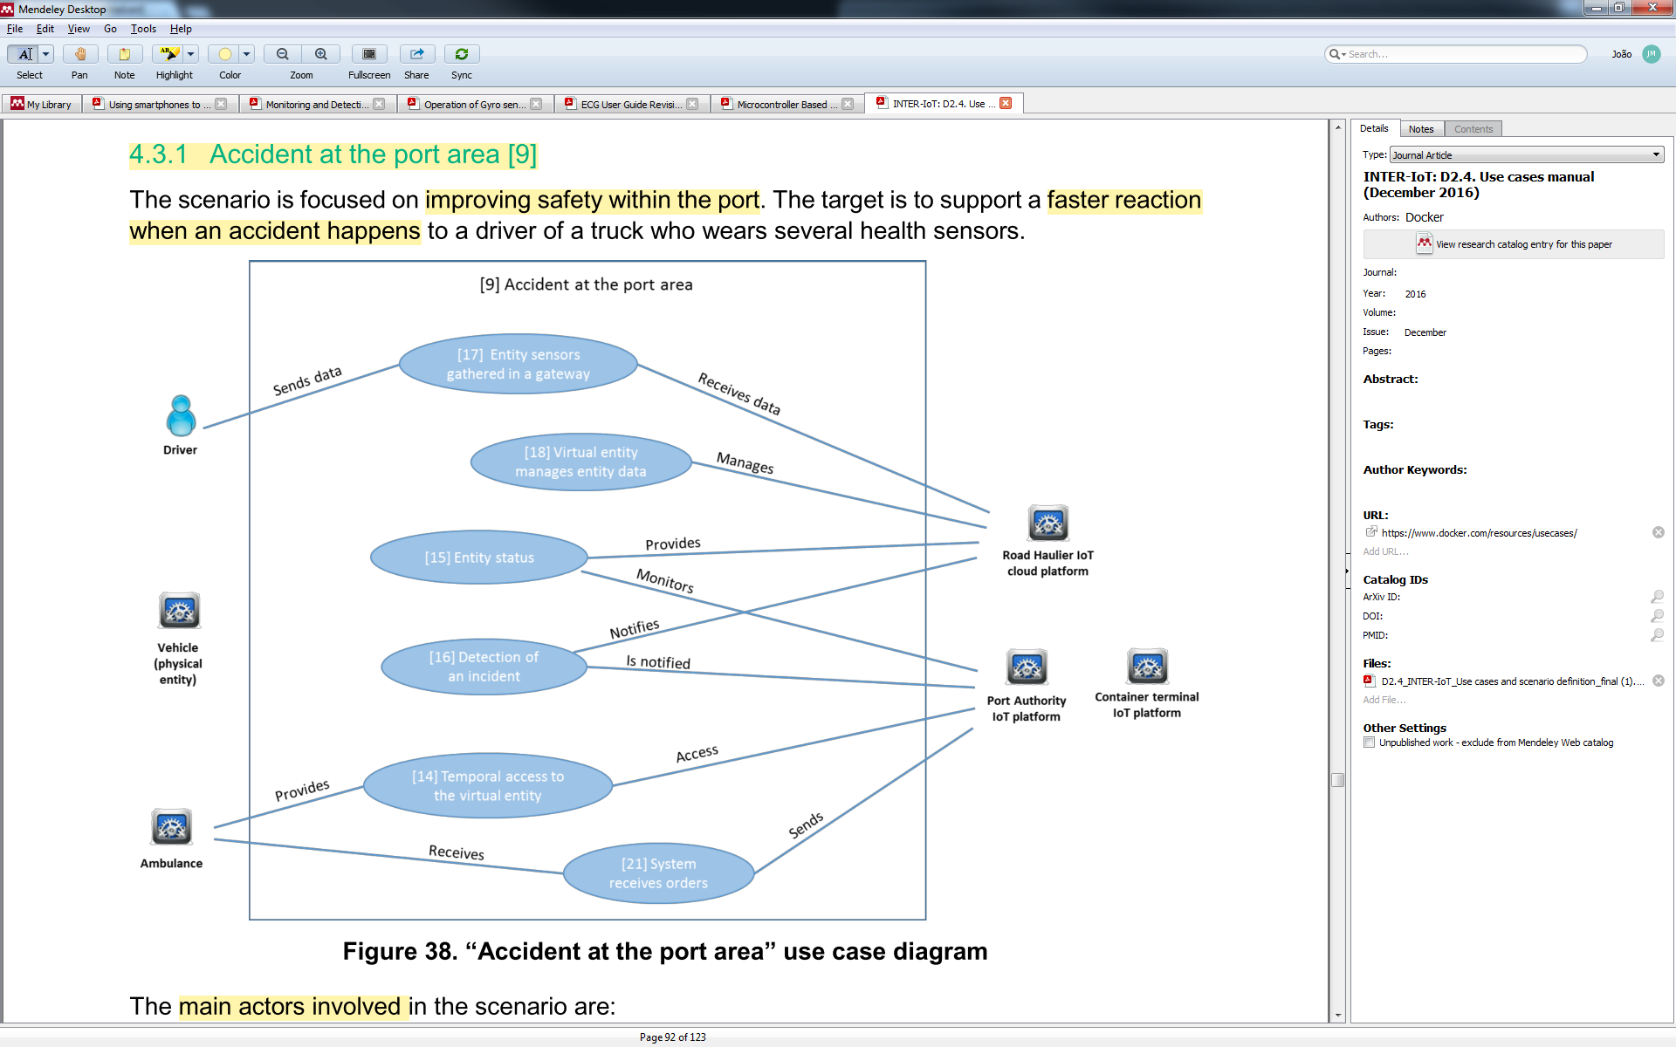

**Figure 4: Use cases diagram of accidents at the port area scenario**

Since the haulier IoT platform comprise, mainly, two types of data (logistics and health), we suggest to compose this system with services offering data provided by the Movildata system (1.5.1) for logistics (location, speed and vehicle information) and services offering data provided by the UNICAL solution for INTER-Health (1.5.7). In addition, this platform can also provide services to access data from the driver’s mobile, such as accelerometer data (1.5.8) and location (mobile GPS). Data related to the terminal where the truck is intended to go can be provided by the platform from the port authority IoT platform (1.5.6), based on the PCS (1.5.2).

<<add data flows here>>

A service will make available

|  |  |  |  |
| --- | --- | --- | --- |
| Data type | Device | Sensor |  |
| Health | Shimmer ECG | Driver’s vital signs |  |
| Logistics | Tachograph | Truck location |  |

|  |  |  |  |
| --- | --- | --- | --- |
| **Sensing** | **Device** | IoT artefact |  |
| Location | Mobile phone | App GPS |  |
| Location | Shimmer ECG | UNICAL platform |  |
| Location | Truck GPS (?) | ? |  |
| Location | Tachograph (?) | ? |  |
| Accelerometer | Mobile phone | App accelerometer (github) |  |
| Accelerometer | Shimmer ECG |  |  |
| Speed |  |  |  |
|  |  |  |  |

To specify each use case we give a general description of how the EWS can address the use case and the specific rules to detect each situation type (ST). Here we will use our approach [11] to correlate temporarily two situations based on Allen’s operators between situations that can be active (is current ongoing) or inactive (occurred in the past). The possible temporal relationships are illustrated in Figure XX and, besides the listed there, we also will use the “over window” relationships, a condition to check the existence of two situations in a window of time.

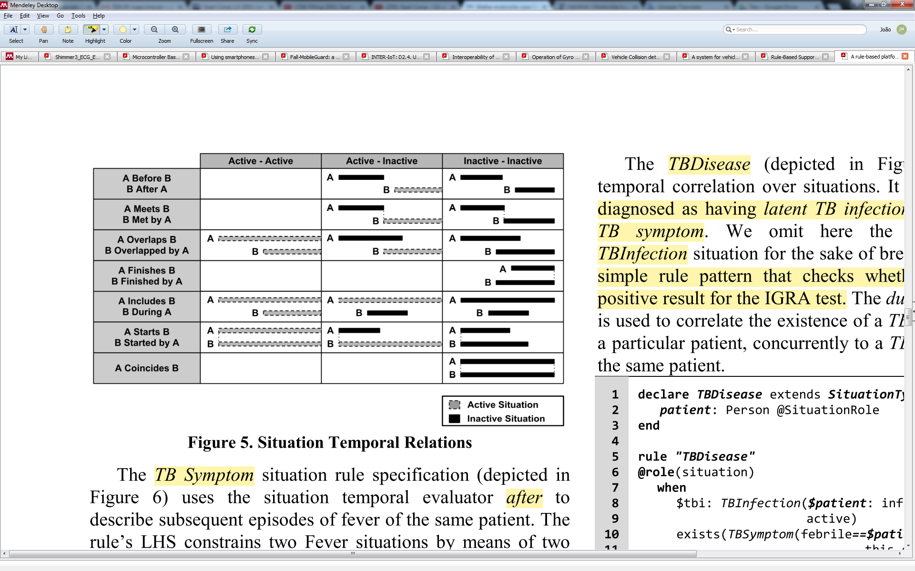

Figure 11: Possible temporal relationships between two situation types [11]

The situation identified will be derived to a message with similar structure of OASIS EDXL-SitRep[19], which is a standard for emergency response messages specifically aimed at transmitting timely situation reports. EDXL-SitRep and EDXL-DE[20] together are intended to speed up incident command decisions needed to respond effectively and adapt to emergency incidents, facilitating communication across various responding organizations. It is planned that the EWS will expose the notification services based on EDXL standards[21]. Figure XX illustrates SitRepType element, which provides properties as the incident information (e.g. location), the severity (extreme, severe, moderate, minor), the urgency (immediate, expected, future, past) and the reporting location. The classification regarding the severity and urgency of the detected situation will be based on the data received by the EWS.

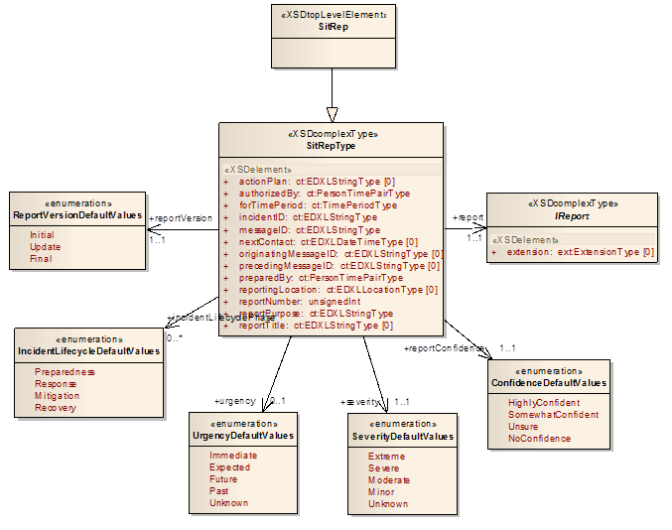

## UC01: Vehicle collision detection

To support the specification of this use case it was required a short review on the most common approaches (research and industrial) to identify accidents through vehicle collision detection with sensors. In general, the approaches use an accelerometer within the vehicle to collect time series data about its location, i.e. the device’s acceleration about the corresponding axes (X, Y, Z), allowing the calculation of the G-Force felt in each instant. Then, for each instant, the detection mechanism compares if the G-Force is above a certain threshold, which is usually 3g for devices deployed in the vehicle chassis [12-15]. According to the patent for “vehicle security with accident notification and embedded driver analytics” (US 9491420 B2) [16], “instances of high acceleration/deceleration are due to a large change in velocity over a very short period of time. These speeds are hard to attain if a vehicle is not controlled by a human driver, which simplifies accident detection since we can assume any instance of high acceleration constitutes a collision involving human drivers”. Figure XX (left) illustrates the car axes (X, Y, Z) and (right) the approach for accident detection based on mobile accelerometer [10].

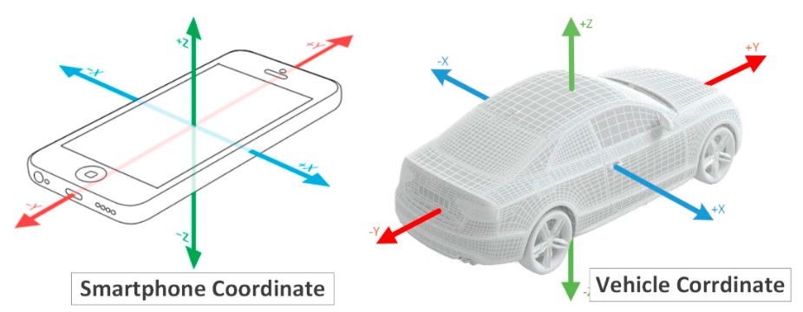 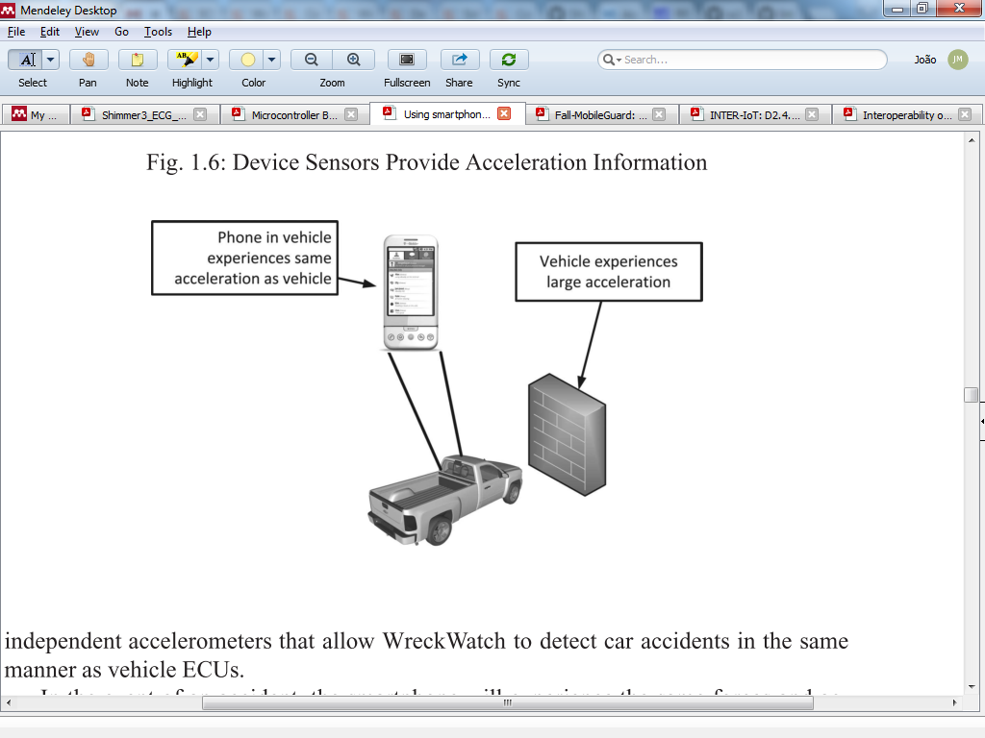

Figure 12: Vehicle coordinates and accident detection based on mobile accelerometer

A research based on microcontroller running collision detection algorithm as a warning system attached into the car chassis [17] uses this approach. As illustrated in Figure XX, the basic flow diagram of this accident alert system first gets the accelerometer data, then computes the G-force and compare it with the threshold (3g). If it is above, then there is a potential vehicle collision detected.

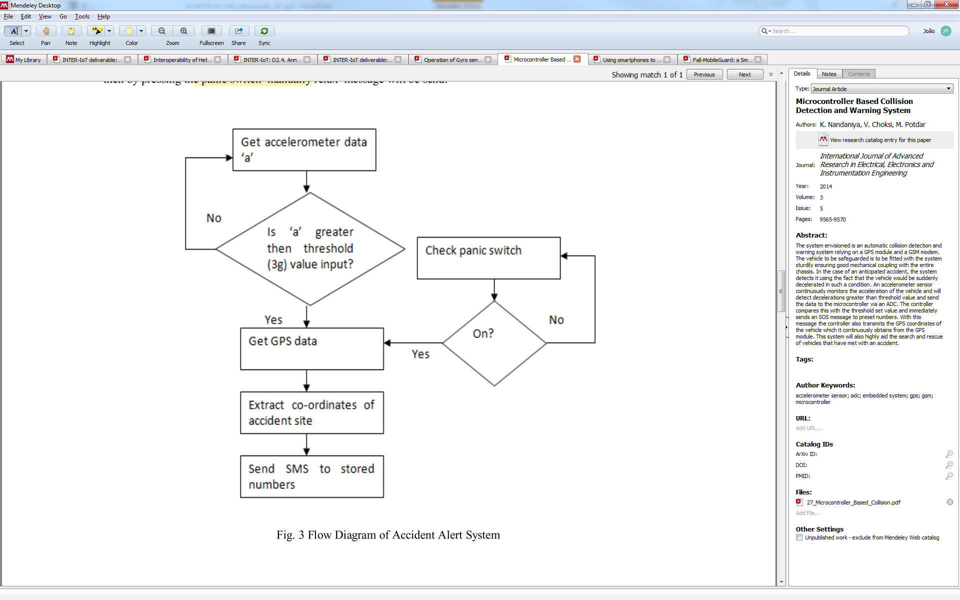

Figure 6: Flow diagram of accident alert system [17]

The calculation of the G-Force can be supported by the cross-axial energy function, following a similar approach of the Fall-MobileGuard solution [18] from the UNICAL partner, which provides a similar approach of collision detection but for fall detection with the Shimmer ECG device, which is equipped with an accelerometer (see section 1.4). For each instant, the sensor sends the data to a mobile application, which computes the cross-axial energy function ($Etot=x^{2}+y^{2}+z^{2}$) and compare to a threshold. If it is above the threshold, then a potential fall is detected. Figure XX illustrates the total cross-axial energy changes in time, notice the peak after 1.5 seconds showing an abnormality, which represents a possible fall. The vehicle detection mechanism will make use of a similar approach.

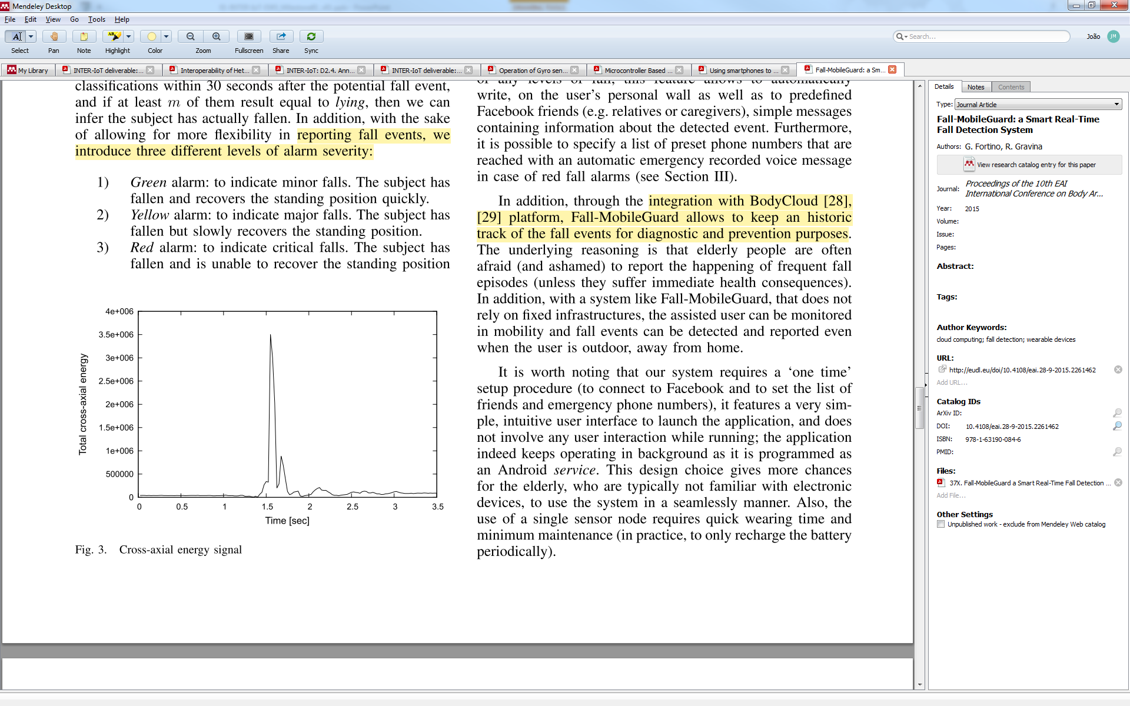

Figure 14: Cross-axial energy signal [18]

According to the Shimmer User Manual [19], accelerometer data can be configured through the mobile application ShimmerCapture[22] (Android v3.0 or later), which also supports real-time data retrieving from the device (Shimmer ECG) to a mobile via Bluetooth (Class 2 Roving Networks RN-42). Two approaches can be used here following the BodyCloud architecture:

(1) each accelerometer instant data produced by the device can be forward from the device to the mobile and from the mobile to the cloud (as a gateway), thus, the EWS monitors the cloud (a subscriber approach); or

(2) the mobile app implements and execute (runtime) the vehicle detection algorithm and only sends instant data to the cloud when the collision is detected.

Obs.1: consider Threshold_VehicleCollision equivalent to 4g.

Obs.2: accelerometerShimmer and accelerometerMobile implements the interface Accelerometer (W3C).

A classification of severity

The situation types (rules) to be addressed in this use case are:

**ST_UC01_01.** Vehicle collision with one accelerometer (Shimmer): activated when collision is detected from the Shimmer’s accelerometer.

IF (ComputeCrossAxialEnergy(accelerometerShimmer) > Threshold_VehicleCollision)

Obs.: Classification of severity and urgency according to accelerometer data (A) and threshold (B) is described in the table below. In summary, if the cross-axial energy computed is greater than the threshold and less than 20% above the threshold, then it might be a light collision (minor severity). If it is in-between 20% and 40%, then the collision is greater (moderate severity), if it is in-between 40% and 60%, then the collision is severe. Above 60% represents a strong impact, thus, an extreme severity, which probably needs immediate urgency for emergency response.

|  |  |  |
| --- | --- | --- |
| **Range** | **Severity** | **Urgency** |
| B < A <= B * 1.2 | Minor | Expected |
| B * 1.2 < A <= B * 1.4 | Moderate | Immediate |
| B * 1.4 < A <= B * 1.6 | Severe | Immediate |
| B * 1.6 < A | Extreme | Immediate |

**ST_UC01_02.** Vehicle collision with one accelerometer (mobile): activated when collision is detected from the mobile’s accelerometer.

IF (A=ComputeCrossAxialEnergy(accelerometerMobile) > B=Threshold_VehicleCollision)

Obs.: same classification of severity and urgency of **ST_UC01_01**.

**ST_UC01_03.** Vehicle collision with two accelerometers (Shimmer and mobile): activated when collision is detected from the Shimmer’s accelerometer and the mobile phone within a configurable delta time.

IF (exists(over window:time(10s, ST_UC01_01 AND ST_UC01_02))

AND ST_UC01_01.Driver = ST_UC01_02.Driver)

Obs.1: we consider an initial value of 10s for delta time. Figure XX illustrates two examples of timeline where this situation type is activated (accident is detected).

Obs.2: notice that one situation type needs to be linked to the other (as an “INNER JOIN”) through some identity object, such as *Driver* or *Truck* or *Device*. Otherwise, this situation type would be activated based on two different trucks, which is incorrect.

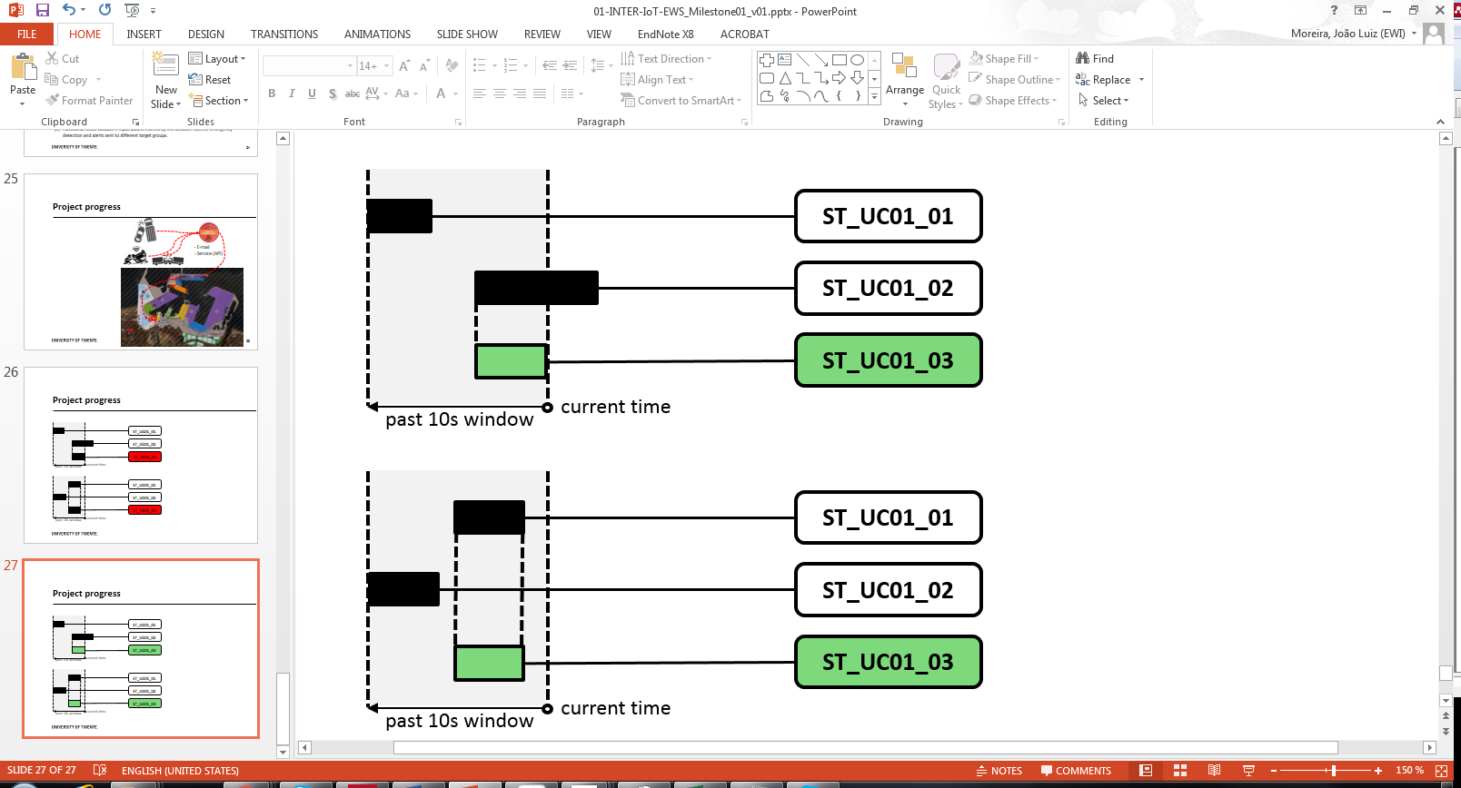

Figure 15: Example timelines for activating ST_UC01_03 with “over window”

Obs.3: same classification of severity and urgency of **ST_UC01_01**.

**ST_UC01_04.** Vehicle collision with one accelerometer (Shimmer or mobile): activated when collision is detected from the Shimmer’s accelerometer or the mobile phone, where the decision is based on the battery consumption of the device (and the effect on data accuracy).

IF (exists(over window:time(10s, ST_UC01_01 OR ST_UC01_02))

AND ST_UC01_01.Driver = ST_UC01_02.Driver)

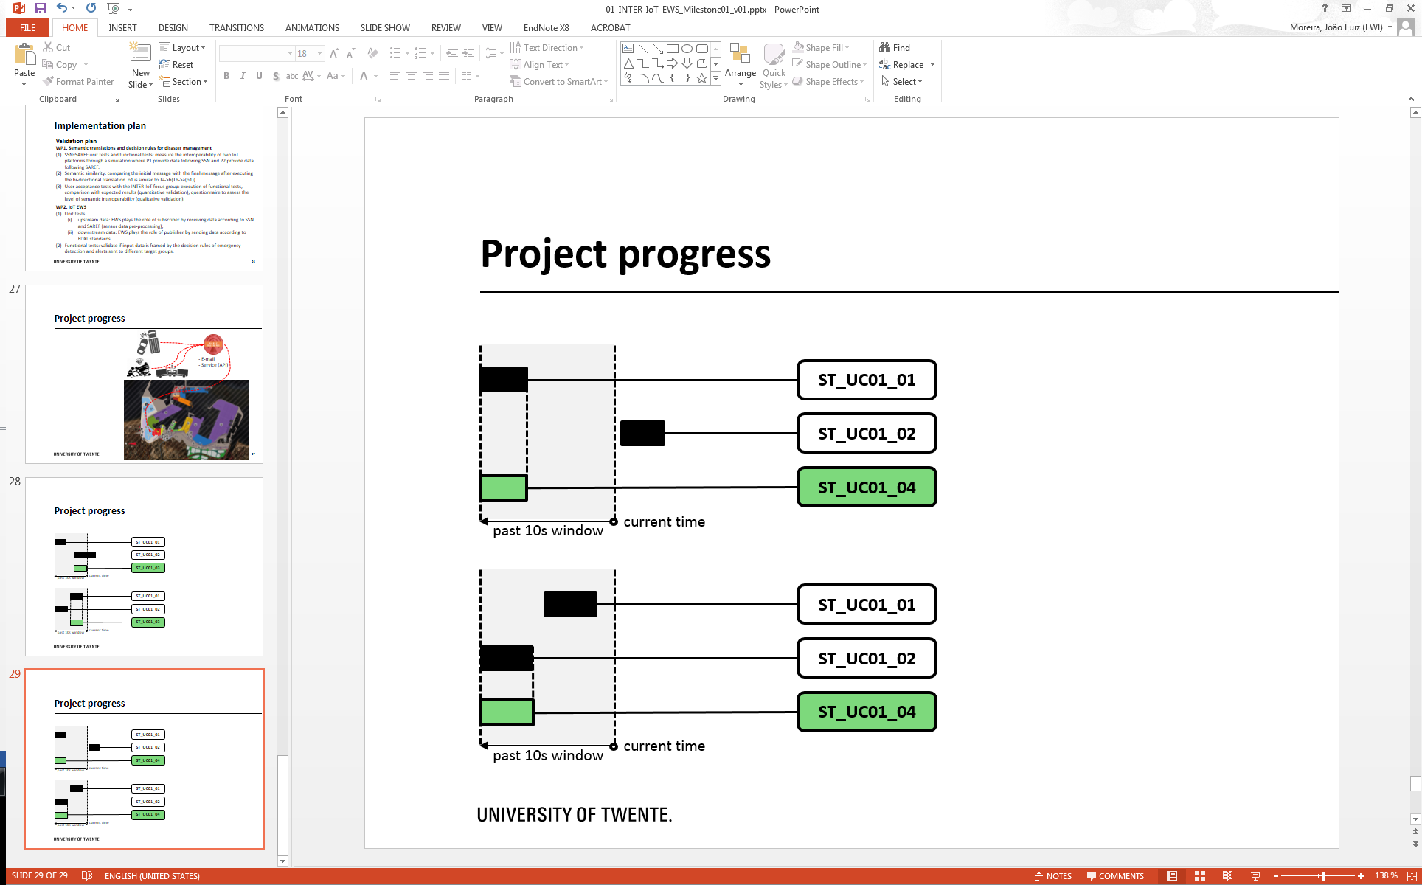

Figure 16: Example timelines for activating ST_UC01_04 with “over window”

Obs.1: we consider an initial value of 10s for delta time. Figure XX illustrates two examples of timeline where this situation type is activated (accident is detected).

Obs.2: same classification of severity and urgency of **ST_UC01_01**.

## UC02: Hazardous health changes

Detect medical issues with the driver by monitoring his/her ECG and derived heart rate, checking possible cardiovascular emergencies. Cardiovascular emergencies are life-threatening disorders that must be recognized as soon as possible to minimize morbidity and mortality. By allowing the EWS to detect cardiovascular emergencies with trucks’ drivers, it is possible to reduce the risk of an accident at the port area. The EWS provides messages that include the information of the cardiovascular emergency situation.

This can be achieved, basically, by using the the INTER-Health IoT solution with Shimmer ECG device attached to the driver’s chest, wired to electrodes, and an Android-based mobile phone, both part of the Body module of the BodyCloud approach implemented with the SPINE framework. Thresholds used by the detection mechanism should be based on existing classifications to detect health risks. For example, target heart rates used for fitness is a classification of indicators that can be used as a baseline for thresholds. Figure XX illustrates such indicators (red, green, yellow, blue) depending on the person’s age. Besides these thresholds, this use case also considers the situations which the driver presents bradycardia and tachycardia, which can be detected with the ECG device (event monitor) [23], as described in the situation types’ definitions below.

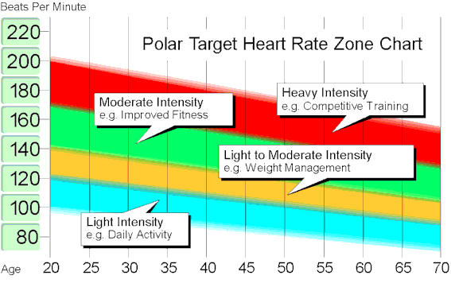

Figure 17: Possible indicators to be used for detecting accidents based on heart rate

Bellow we list the situation types that the EWS can implement:

**ST_UC02_01.** Driver suffers bradycardia: a slow heart rate typically defined as under 60 bpm in adults [24], which can cause fatigue, weakness, dizziness and fainting, thus, it is a risk for the occurrence of an accident.

Threshold_Bradycardia = 60 bpm

IF (ComputeBPM(ecgShimmer) < Threshold_Bradycardia)

Obs.: Classification of severity and urgency according to ComputeBPM output (A) and the threshold (B) is described in the table below. In summary, if the BPM calculated is less than the threshold and greater than 90% of the threshold, then it might be a light bradycardia (minor severity). If it is in-between 80% and 90%, then the bradycardia is greater (moderate severity), if it is in-between 70% and 80%, then the bradycardia is severe. Below 70% represents a strong bradycardia, thus, an extreme severity, which probably needs immediate urgency for emergency response.

|  |  |  |
| --- | --- | --- |
| **Range** | **Severity** | **Urgency** |
| B > A >= B * 0.9 | Minor | Expected |
| B * 0.9 > A >= B * 0.8 | Moderate | Immediate |
| B * 0.8 > A >= B * 0.7 | Severe | Immediate |
| B * 0.7 > A | Extreme | Immediate |

**ST_UC02_02.** Driver suffers tachycardia: “a heart rate that exceeds the normal resting rate (…) over 100 beats per minute is accepted as tachycardia in adults”. This threshold can vary on children (from 119 to 182) depending on the age. We ignored these thresholds since here we’re considering only drivers. Although heart rates above the resting rate may be normal (e.g. exercise), it can also be abnormal (e.g. electrical problems in the heart), which may be a risk of accident if the person is driving.

Threshold_Tachycardia = 100 bpm

IF (ComputeBPM(ecgShimmer) > Threshold_Tachycardia)

Obs.: Classification of severity and urgency according to ComputeBPM output (A) and the threshold (B) is described in the table below. In summary, if the BPM calculated is greater than the threshold and less than threshold more 10%, then it might be a light tachycardia (minor severity). If it is in-between 10% and 20%, then the tachycardia is greater (moderate severity), if it is in-between 20% and 30%, then the tachycardia is severe. Greater than 30% represents a strong tachycardia, thus, an extreme severity, which probably needs immediate urgency for emergency response.

|  |  |  |
| --- | --- | --- |
| **Range** | **Severity** | **Urgency** |
| B < A <= B * 1.1 | Minor | Expected |
| B * 1.1 < A <= B * 1.2 | Moderate | Immediate |
| B * 1.2 < A <= B * 1.3 | Severe | Immediate |
| B * 1.3 < A | Extreme | Immediate |

**ST_UC02_03.** Driver suffers tachycardia (long period): as described above, tachycardia can be a normal condition, but it “complications of tachycardia vary in severity depending on factors such as the rate and duration of rapid heart rate” [25], which can cause sudden death. This rule checks if the duration of ST_UC02_02is above the threshold of 1 minute or if there were consecutive, i.e. multiple occurrences (more than one) of ST_UC02_02 during the threshold of 5 minutes.

Threshold_TachycardiaDuration = 1min

Threshold_TachycardiaDurationMultipleOccurences = 5min

IF (duration(ST_UC02_02) > Threshold_TachycardiaDuration

OR exists(ST_UC02_02 after[0, Threshold_TachycardiaDurationMultipleOccurences]) ST_UC02_02)

Obs.1: Figure XX illustrates two examples of timeline where this situation type is activated.

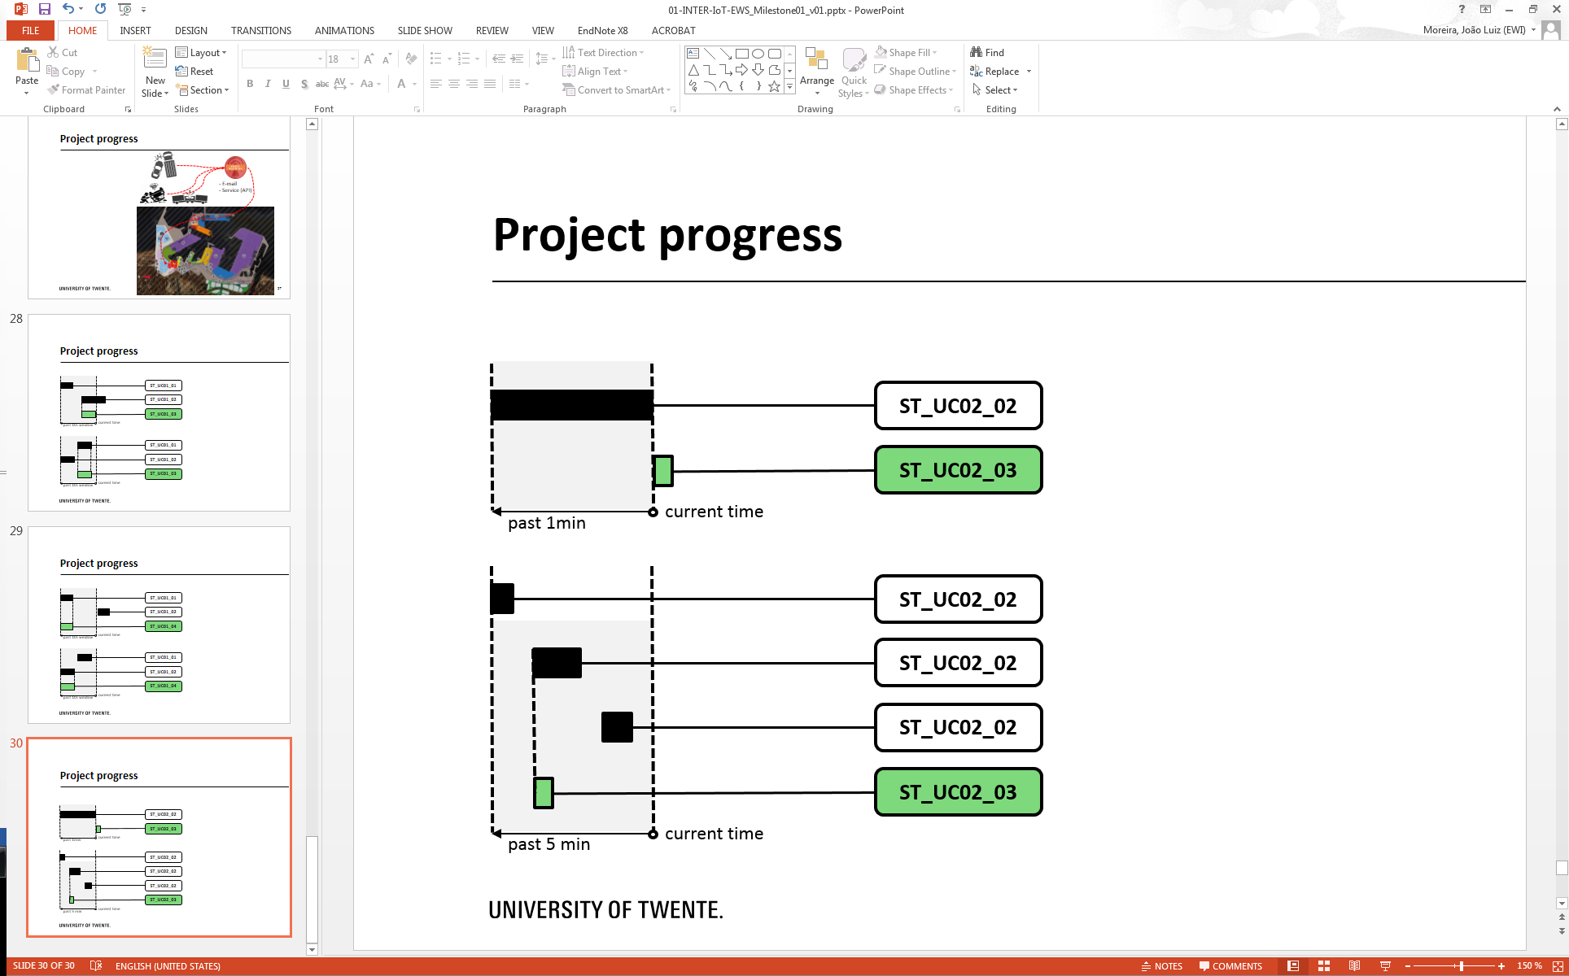

Figure 18: Example timelines for activating ST_UC02_03

Obs.2: Classification of severity is Extreme and urgency is Immediate regardless of the BPM calculated.

**ST_UC02_04.** Driver presents large variations of heart rate: situations in which there are large variations of heart rate can represent a health issue with the driver or even the occurrence of an accident. This rule will check whether these variations occur. If there is a variation of more than 50% of the heart rates collected during a period of 1 minute, then this situation is detected.

Threshold_VariationHR = 50%

Threshold_VariationHHTime = 1 minute

IF (exists(over window:time(Threshold_VariationHHTime, variation(driver.HH > Threshold_VariationHH))))

**ST_UC02_05.** Driver stressed: this use case will be based on the research of UNICAL [20] for stress detection based on Cardiac Defense Response (CDR). “CDR is a physiological reaction with a protective and primal defensive role; however, excessive CDR responding can lead to severe psychological disorders (such as stress, anxiety, phobia, and depression), if maintained (either in intensity or frequency) for long periods”. Thus, here we will follow an approach similar to the CDR detection method (Figure XX top), which is based on the “method of the medians” and is used to calculate the non-stationary index (NSI) with the data provided by the ECG device. Then, this index is compared to a threshold (empirically assigned by this research). If the index is less than the threshold, then the CDR is detected, meaning that the driver presents a high level of stress and needs to stop driving to reduce the risk of accidents.

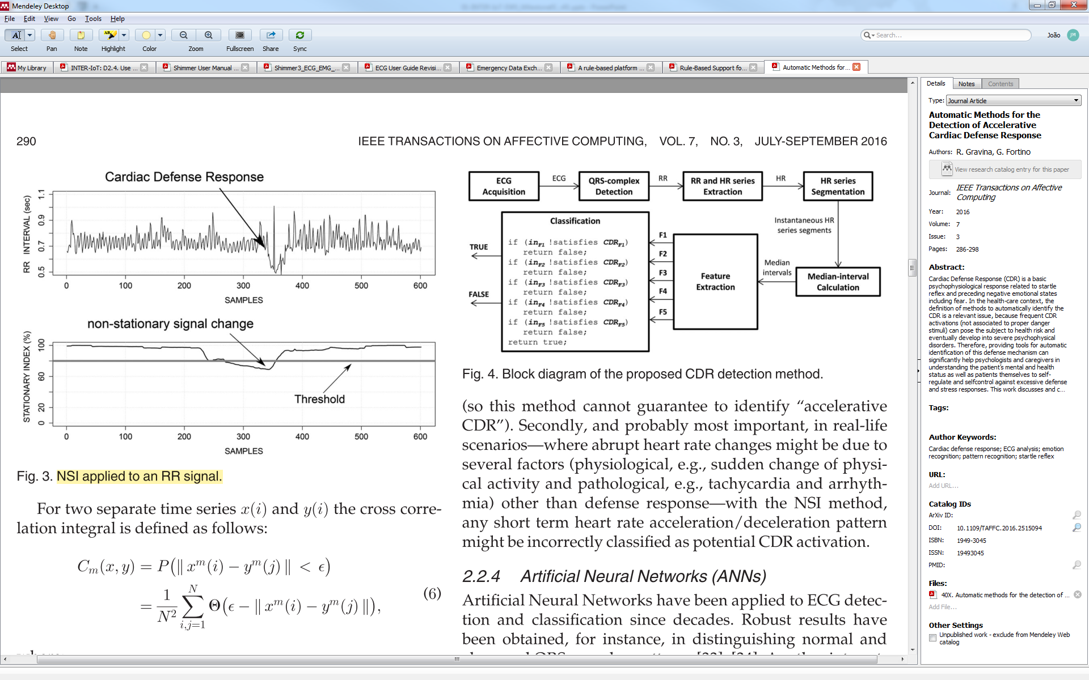

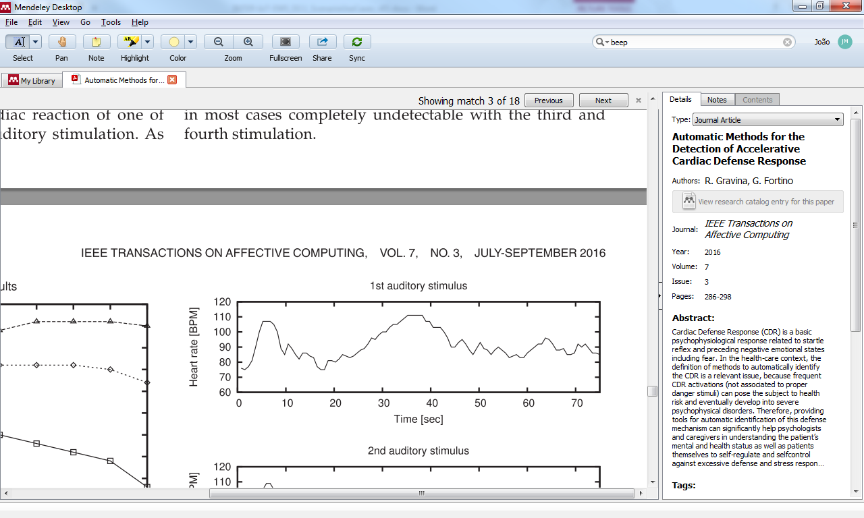

Figure 19: CDR detection approach (on top) and an example of CDR detected (bottom)

Other existing classifications for detecting health risks can be used, as described in [21].

Check:

Yi, W., Chan, A. P. C., Wang, X., & Wang, J. (2016). Development of an early-warning system for site work in hot and humid environments: A case study. *Automation in Construction*, *62*, 101–113. https://doi.org/10.1016/j.autcon.2015.11.003

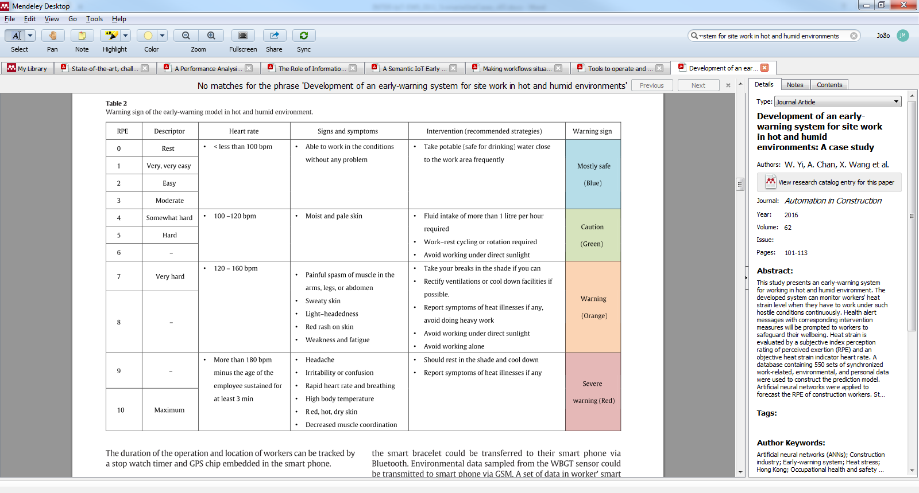

## UC03: Temporal relations (UC01 ~ UC02)

This use case exploits the possible temporal relations between UC01 and UC02 towards the detection of an accident in the port area. For example, if a truck collision is detected from the accelerometers of the medical and mobile devices (ST_UC01_03) and right after (e.g. within 1-2 minutes) the driver’s vital signs change dramatically (ST_UC02_04) then there is a high probability that a severe accident occurred, the driver is injured and he/she requires urgent medical help. Notice that the temporal relationship (“right after”) is crucial to integrate these use cases.

Below we list the situation types that the EWS can implement:

**ST_UC03_01.** Vehicle collision followed by bradycardia: a slow heart rate right after (within 2 minutes) a collision is detected can represent that an accident just occurred and the driver is probably injured. Severity Extreme and urgency Immediate.

Threshold_RightAfter = 2 minutes

IF (exists(ST_UC02_01 after[0, Threshold_RightAfter] ST_UC01_03)

**ST_UC03_02.** Vehicle collision during large variations of heart rate: Similar to the situation described above, this rule detects if occurred an instance of ST_UC01_03 (collision detected) within the interval of time of the ST_UC02_04 (variations of heart rate). Severity Extreme and urgency Immediate.

IF (exists(ST_UC01_03 during ST_UC02_04)

AND ST_UC01_03.Driver = ST_UC02_04.Driver)

**ST_UC03_03.** Vehicle collision during or followed by large variations of heart rate: This rule detects if an instance of ST_UC01_03 (collision detected) occurred during or right before the ST_UC02_04 (variations of heart rate). Severity Extreme and urgency Immediate.

IF ((exists(ST_UC01_03 during ST_UC02_04) OR exists(ST_UC02_04 after[0, Threshold_RightAfter] ST_UC01_03))

AND ST_UC01_03.Driver = ST_UC02_04.Driver)

**ST_UC03_04.** Vehicle collision after stress detected: This situation is identified if a collision occurred right after stress is detected. This rule detects if an instance of ST_UC01_03 (collision detected) occurred during or right after the ST_UC02_05 (driver stressed). Severity Extreme and urgency Immediate.

IF (exists(ST_UC01_03 after[0, Threshold_RightAfter] ST_UC02_05))

AND ST_UC01_03.Driver = ST_UC02_05.Driver)

## UC04: Wrong-way driving

Wrong way = opposite direction .

## UC05: Accident involving dangerous goods

The international regulation from UN is in the following link

<http://www.unece.org/trans/danger/what.html>

“At the United Nations level, all work related to the transport of dangerous goods is coordinated by the Economic and Social Council (ECOSOC) Committee of Experts on the Transport of Dangerous Goods (TDG) and on the Globally Harmonized System of Classification and Labelling (GHS), which produces the "Recommendations on the Transport of Dangerous Goods", also called the "Orange Book" and the Globally Harmonized System of Classification and Labelling of Chemicals.”

<https://www.porttechnology.org/news/top_four_dangerous_shipping_statistics>

Ellis, J. (2011). Analysis of accidents and incidents occurring during transport of packaged dangerous goods by sea. *Safety Science*, *49*(8–9), 1231–1237. https://doi.org/10.1016/j.ssci.2011.04.004

<http://www.hse.gov.uk/ports/dangerous-goods.htm>

<http://www.portseurope.com/valencia-port-simulates-fire-accident-to-test-emergency-plan/>

## Risks identified for the implementation of the use cases

* Requirements related to the haulier platforms might not be addressed since the haulier IoT platform won’t be built.
* Missing the list of emergency services in the vicinity
* “phones can be dropped (and generate false positives) and the phone is not directly connected to the vehicle.”
* Risk for validation: non historic data available for past accidents

# References

1. Ganzha, M., et al., *Semantic interoperability in the Internet of Things: An overview from the INTER-IoT perspective.* Journal of Network and Computer Applications, 2016.

2. INTER-IoT, *INTER-IoT deliverable: D2.4. Use cases manual*. 2016.

3. Moreira, J.L.R., et al. *Ontology-driven Conceptual Modeling for Early Warning Systems: Redesigning the Situation Modeling Language*. in *International Conference on Model-Driven Engineering and Software Development (MODELSWARD)*. 2017.

4. Moreira, J.L.R., et al., *Towards ontology-driven situation-aware disaster management.* Journal of applied ontology, 2015. **10**(3-4): p. 339-353.

5. INTER-IoT, *INTER-IoT deliverable: D4.1. Initial Reference IoT Platform Meta-Architecture and Meta Data Model (15/01/2017)*. 2017.

6. INTER-IoT, *INTER-IoT deliverable: D2.3. Requirements and business analysis*. 2016.

7. Fortino, G., et al., *BodyCloud: A SaaS approach for community Body Sensor Networks.* Future Generation Computer Systems, 2014. **35**: p. 62-79.

8. Wieringa, R., *Design Science Methodology for Information Systems and Software Engineering.* Springer Berlin Heidelberg, 2014: p. 493.

9. Mucheru, G., *Operation of Gyro sensor and 3-axis Accelerometer*. 2014, Helsinki Metropolia University of Applied Sciences.

10. Thompson, C., et al., *Using Smartphones to Detect Car Accidents and Provide Situational Awareness to Emergency Responders*, in *Mobile Wireless Middleware, Operating Systems, and Applications: Third International Conference, Mobilware 2010, Chicago, IL, USA, June 30 - July 2, 2010. Revised Selected Papers*, Y. Cai, et al., Editors. 2010, Springer Berlin Heidelberg: Berlin, Heidelberg. p. 29-42.

11. Costa, P.D., et al., *Rule-Based Support for Situation Management*, in *Fusion Methodologies in Crisis Management: Higher Level Fusion and Decision Making*, G. Rogova and P. Scott, Editors. 2016, Springer International Publishing: Cham. p. 341-364.

12. Mane, A. and J. Rana. *Vehicle Collision detection and Remote Alarm Device using Arduino*. 2014.

13. San Vicente Foronda, L., *Automotive Events Detection using MEMS Accelerometers.* 2009: p. 129-129.

14. Sulochana, B. and B.A.S.M. Babu, *Monitoring and Detecting Vehicle Based On Accelerometer and MEMS Using GSM and GPS Technologies.* International Journal of Computer Science Trends and Technology (IJCST), 2014. **2**(4): p. 55-59.

15. Ibrahim, H.A., A.K. Aly, and B.H. Far. *A system for vehicle collision and rollover detection*. in *2016 IEEE Canadian Conference on Electrical and Computer Engineering (CCECE)*. 2016.

16. MIMAR, T., *Vehicle security with accident notification and embedded driver analytics*. 2016, Google Patents.

17. Nandaniya, K., V. Choksi, and M.B. Potdar, *Microcontroller Based Collision Detection and Warning System.* International Journal of Advanced Research in Electrical, Electronics and Instrumentation Engineering, 2014. **3**(5): p. 9565-9570.

18. Fortino, G. and R. Gravina, *Fall-MobileGuard: a smart real-time fall detection system*, in *Proceedings of the 10th EAI International Conference on Body Area Networks*. 2015, ICST (Institute for Computer Sciences, Social-Informatics and Telecommunications Engineering): Sydney, New South Wales, Australia. p. 44-50.

19. Shimmer, *Shimmer User Manual Revision 3p*. 2017, Realtime Technologies Ltd.

20. Gravina, R. and G. Fortino, *Automatic Methods for the Detection of Accelerative Cardiac Defense Response.* IEEE Transactions on Affective Computing, 2016. **7**(3): p. 286-298.

21. Barfod, C., et al., *Abnormal vital signs are strong predictors for intensive care unit admission and in-hospital mortality in adults triaged in the emergency department - a prospective cohort study.* Scandinavian Journal of Trauma, Resuscitation and Emergency Medicine, 2012. **20**(1): p. 28.

1. <http://docs.oasis-open.org/emergency/TEP-HL7v2-transforms/v1.0/TEP-HL7v2-transforms-v1.0.html>
2. <http://www.shimmersensing.com//products/ecg-development-kit>
3. <https://dtc.jrc.ec.europa.eu/dtc_smart_tachograph.php>
4. <https://github.com/raffy1982/spine-project>
5. <http://spine.deis.unical.it/spine.html>
6. <http://www.shimmersensing.com>
7. <https://github.com/raffy1982/spine-project/tree/master/Spine_nodes>
8. <https://github.com/ShimmerResearch/tinyos-shimmer>
9. <http://www.shimmersensing.com//products/ecg-development-kit>
10. <https://github.com/ShimmerResearch/shimmer3>
11. <http://www.shimmersensing.com/products/shimmercapture>
12. <http://www.shimmersensing.com/products/shimmer-9dof-calibration-for-android>
13. <http://www.universaal.info/>
14. <https://github.com/universAAL/platform>
15. <http://movildata.com/en/>
16. <https://github.com/telerik/Android-samples/tree/master/Blogs/Seismograph/V2>
17. <https://learn.sparkfun.com/tutorials/accelerometer-basics>
18. <https://www.w3.org/TR/accelerometer/>

    <https://github.com/w3c/accelerometer>
19. <http://docs.oasis-open.org/emergency/edxl-sitrep/v1.0/edxl-sitrep-v1.0.html>
20. <http://docs.oasis-open.org/emergency/edxl-de/v2.0/edxl-de-v2.0.html>
21. <https://www.oasis-open.org/committees/emergency/>
22. <http://www.shimmersensing.com/products/shimmercapture-for-android>
23. <http://www.mayoclinic.org/diseases-conditions/bradycardia/diagnosis-treatment/diagnosis/dxc-20321665>

    <http://www.mayoclinic.org/diseases-conditions/tachycardia/diagnosis-treatment/diagnosis/dxc-20253919>
24. <https://en.wikipedia.org/wiki/Bradycardia>
25. <http://www.mayoclinic.org/diseases-conditions/tachycardia/symptoms-causes/dxc-20253873>